# EX1: Update Package Settings

Objective: Enable the calculation service introduced in Winter ’16 so advanced features are available throughout further exercises.

1. Navigate to Setup | Installed Packages
2. Click Configure  
   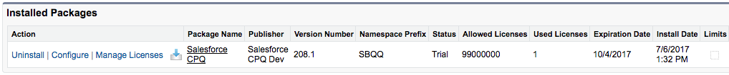
3. Click Authorize new calculation service  
   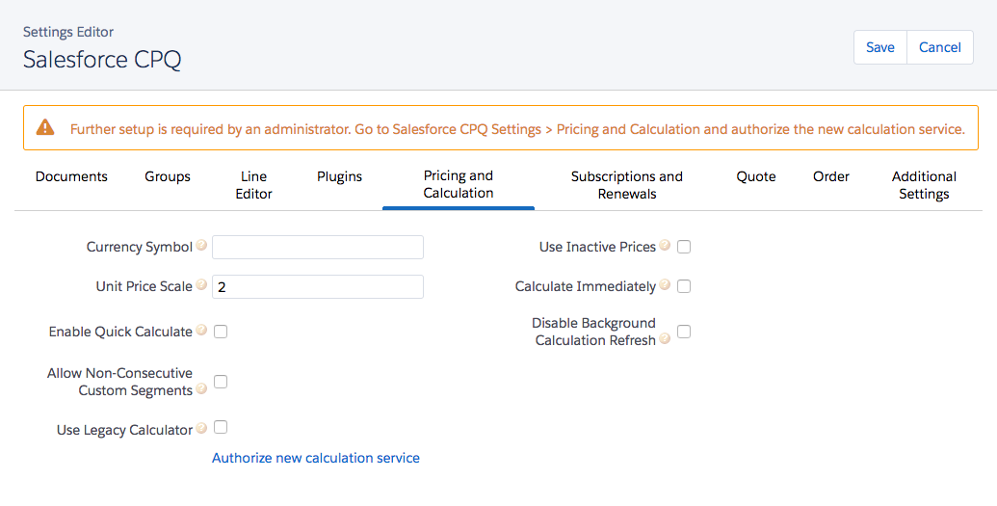
4. Click Allow  
   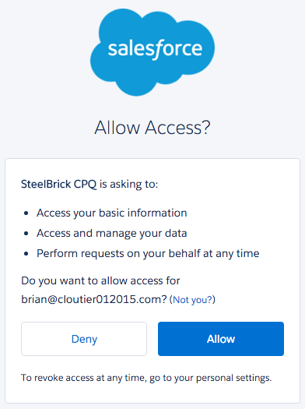

# EX2: Update Product Fields

Objective: Change how specific products behave when added to a Salesforce CPQ quote, mainly in regards to subscription pricing calculations.

1. Navigate to Products | Cloud Storage 1GB
2. Update field values, then Save  
   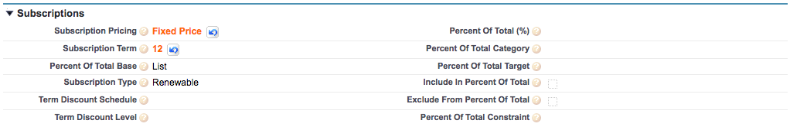
3. Update remaining products per table:

| Product Code | Sub Pricing | Sub Term | PoT Category | PoT % | Qty Edit | Non Disc |
| --- | --- | --- | --- | --- | --- | --- |
| ADMINHOUR | Fixed Price | 1 |  |  |  |  |
| AP-TBDISPLAY |  |  | Hardware |  |  |  |
| CLOUDSTORAGE | Fixed Price | 12 |  |  |  |  |
| ITPROPACK |  |  |  |  | False | True |
| LJ-PRINTER |  |  | Hardware |  |  |  |
| LDWARRANTY | Percent of Total | 12 | Hardware | 5.0 |  |  |
| MS-OFFICE365 | Fixed Price | 1 |  |  |  | True |
| WARRANTY | Percent of Total | 12 | Hardware | 0.5 |  |  |
| WIFIROUTER |  |  | Hardware |  |  |  |

# EX3: Create Sample CPQ Quote

Objective: Create a Salesforce CPQ quote to experience the typical process a sales rep might complete, as well as create a quote record that may be used for further testing.

1. Navigate to Accounts tab
2. Click New  
   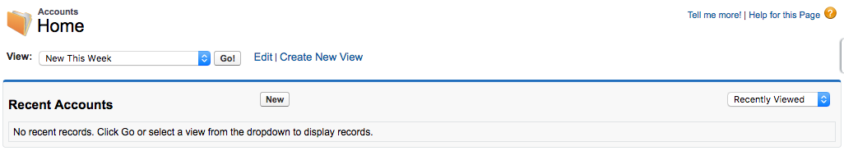
3. Set field values, then Save  
   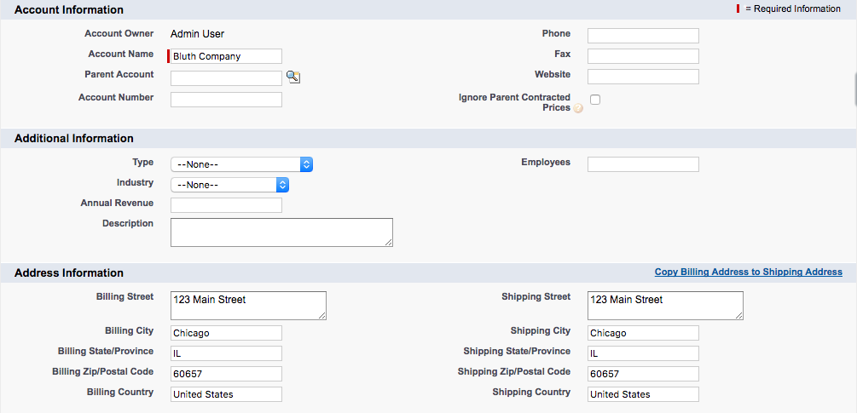
4. Click New Contact  
   
5. Set field values, then Save  
   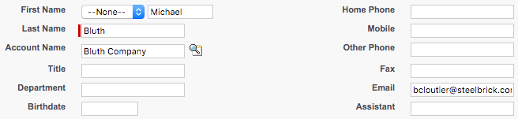
6. Click New Opportunity  
   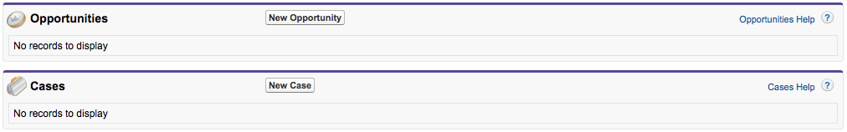
7. Set field values, then Save  
   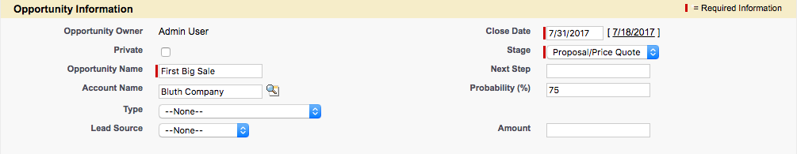
8. Click New Quote  
   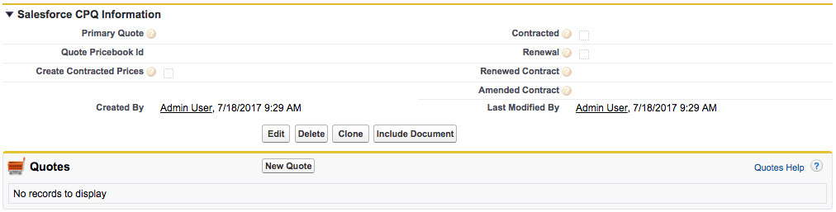
9. Set field values, then Save  
   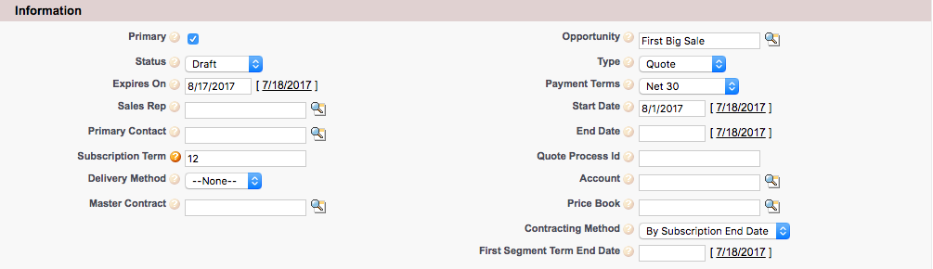
10. Click Save to Choose Price Book popup  
    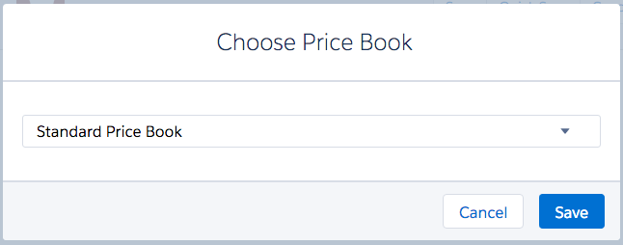
11. Click Add Products  
    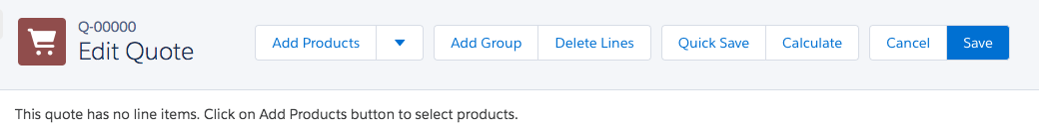
12. Choose these products, then click Select  
    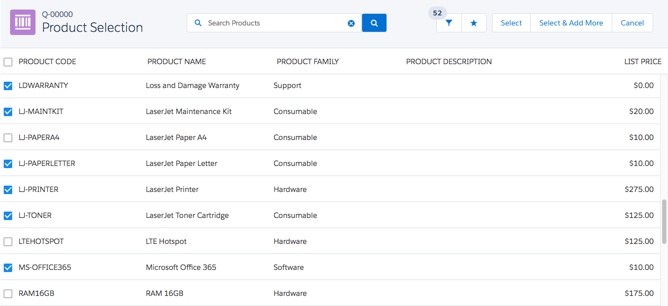
13. Enter these quantities, click Calculate to verify subtotal, then click Save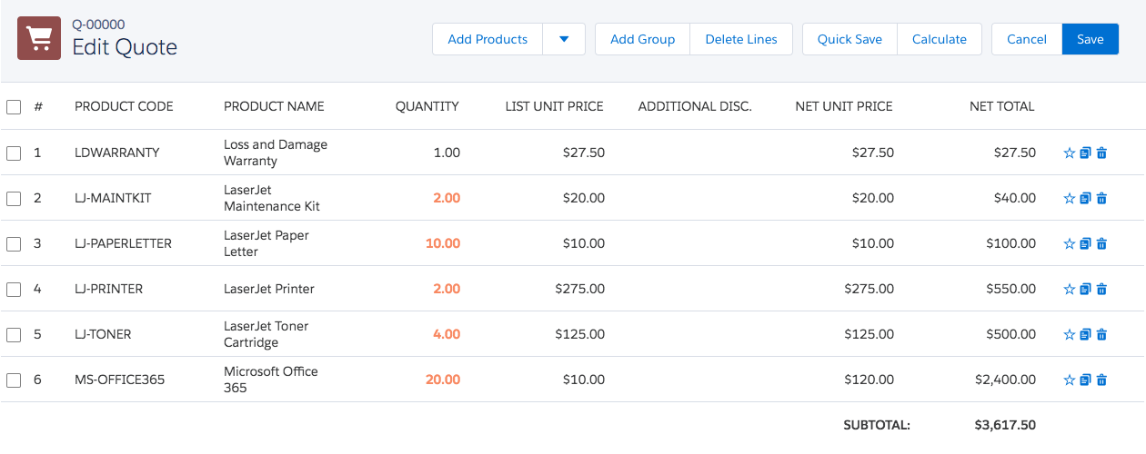

# EX4: Create Features

Objective: Create Features that will give the ITPROPACK bundle some organization once Product Options are created. The effect of this exercise is only seen after EX5 is complete.

1. Navigate to the ITPROPACK product
2. Click New Product Feature in the Features related list  
   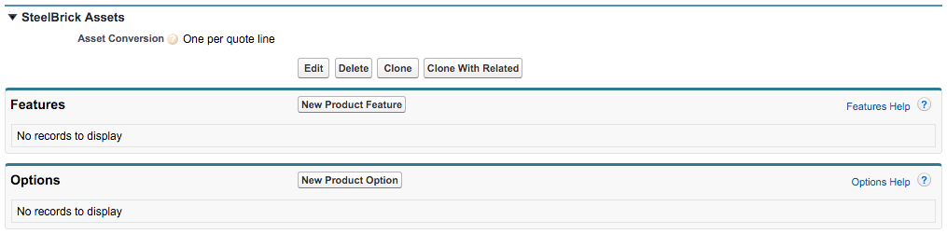
3. Set field values, then Save  
   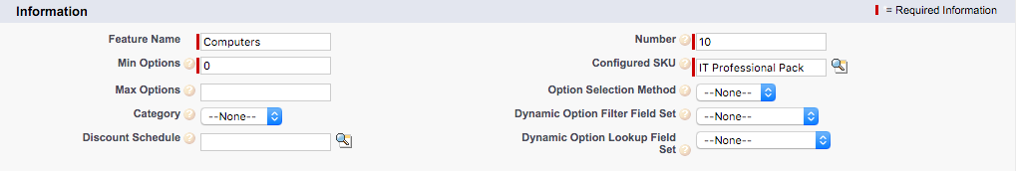
4. Create remaining features per screenshot:  
   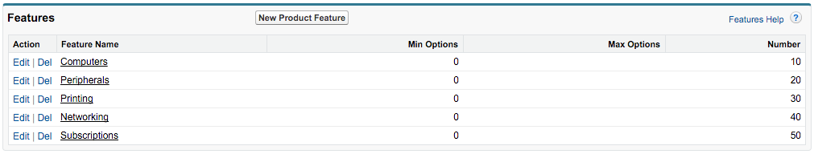

# EX5: Create Options

Objective: Create a series of Product Options to be presented when the ITPROPACK is configured, defining properties that effect how the sales rep may interact with the options. Also, update the ITPROPACK so that users enter configuration immediately after selecting the product.

1. Navigate to the ITPROPACK product
2. Click New Product Option in the Options related list  
   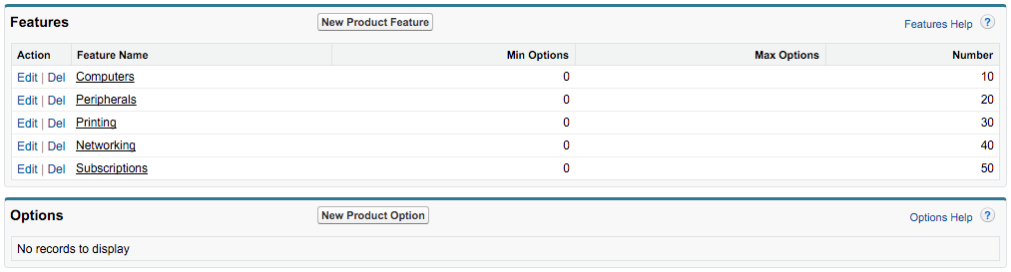
3. Set field values, then Save  
   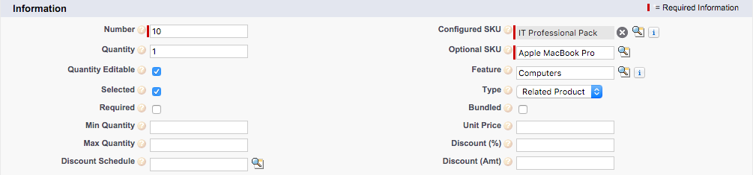
4. Create remaining options per table:

| Optional SKU | Feature | Type | Num | Qty | Qty Edit | Select | Min Qty |
| --- | --- | --- | --- | --- | --- | --- | --- |
| Apple MacBook Pro | Computers | Related Product | 10 | 1 | True | True |  |
| Apple US Keyboard | Peripherals | Related Product | 10 | 1 | True |  |  |
| Apple UK Keyboard | Peripherals | Related Product | 20 | 1 | True |  |  |
| Apple Magic Mouse | Peripherals | Related Product | 30 | 1 | True |  |  |
| Apple Thunderbolt Display | Peripherals | Related Product | 40 | 1 | True |  |  |
| LaserJet Printer | Printing | Accessory | 10 | 1 | True |  |  |
| LaserJet Toner Cartridge | Printing | Accessory | 20 | 1 | True |  |  |
| LaserJet Maintenance Kit | Printing | Accessory | 30 | 1 |  |  |  |
| LaserJet Paper Letter | Printing | Related Product | 40 | 1 | True |  |  |
| LaserJet Paper A4 | Printing | Related Product | 50 | 1 | True |  |  |
| WiFi Router | Networking | Accessory | 10 | 1 |  |  |  |
| WiFi Access Point | Networking | Accessory | 20 | 1 |  |  |  |
| WiFi Installation | Networking | Accessory | 30 | 1 |  |  |  |
| Warranty | Subscriptions | Accessory | 10 | 1 |  |  |  |
| Loss and Damage Warranty | Subscriptions | Accessory | 20 | 1 |  |  |  |
| Microsoft Office 365 | Subscriptions | Related Product | 30 | 1 | True |  |  |
| Cloud Storage 1GB | Subscriptions | Related Product | 40 |  |  |  |  |
| Admin Hour | Subscriptions | Accessory | 50 | 20 | True |  | 10 |

1. Navigate to the ITPROPACK product
2. Set field values, then Save  
   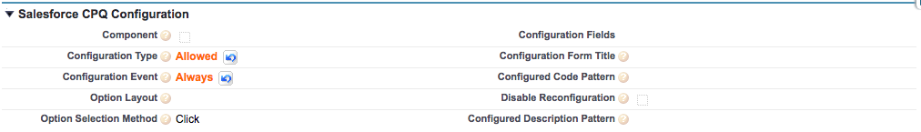

# EX6: Create Option Constraints

Objective: Prevent the sales rep from mistakenly selling products such as the WiFi Access Point and WiFi Installation without the requisite WiFi Router. Also, prevent the sales rep from selling more than one type of warranty. All constraints apply only to the ITPROPACK.

1. Navigate to the ITPROPACK product
2. Click New Option Constraint in the Option Constraints related list  
   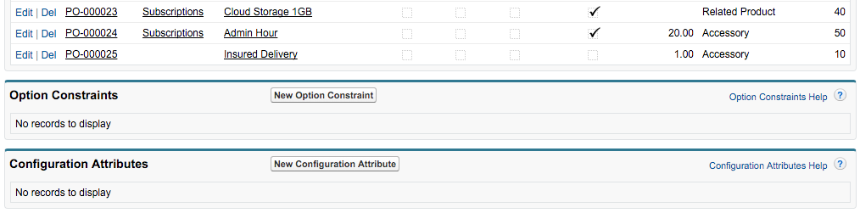
3. Set field values, then click Save & New  
   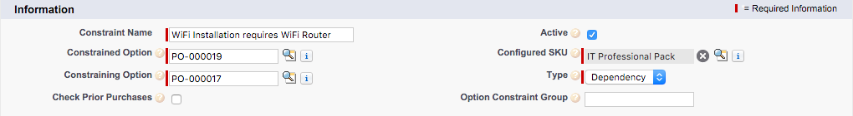

***Installation Option***

***Router Option***

1. Set field values, then click Save & New  
   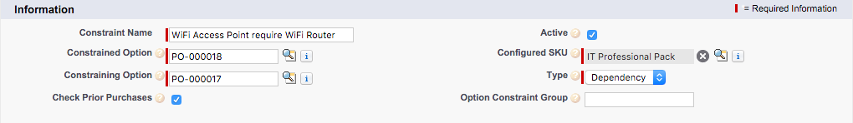

***Access Point Option***

***Router Option***

1. Set field values, then Save  
   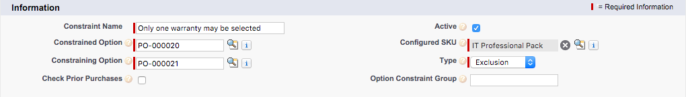

***LD Warranty Option***

***Warranty Option***

# EX7: Create Option Constraint with Grouping

Objective: Prevent the sales rep from selling Cloud Storage unless both the WiFi Router AND the WiFi Access Point have been selected. This constraint only applies to the ITPROPACK.

1. Navigate to the ITPROPACK product
2. Click New Option Constraint in the Option Constraints related list  
   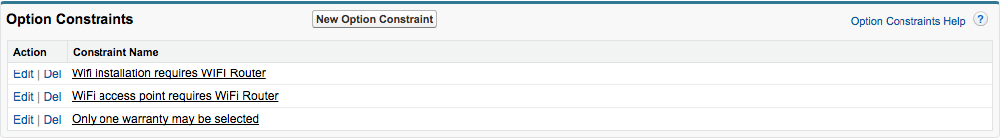
3. Set field values, then click Save & New  
   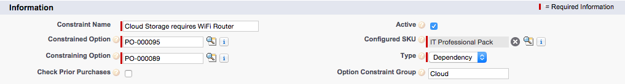

***Cloud Storage Option***

***Router Option***

1. Set field values, then Save  
   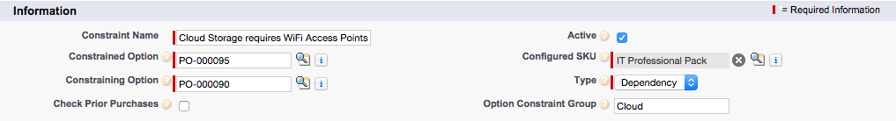

***Cloud Storage Option***

***Access Point Option***

# EX8: Printer Options Product Rule

Objective: Automatically check the LaserJet toner and maintenance kit options when the sales rep selects the printer options, so as to remind the sales rep that those options are frequently sold together when configuring the ITPROPACK.

1. Navigate to Product Rule tab
2. Click New  
   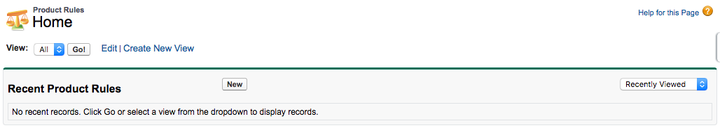
3. Set field values, then Save  
   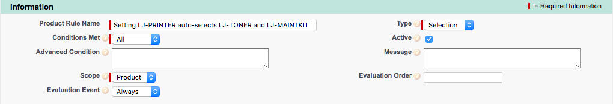
4. Click New Configuration Rule in Configuration Rules  
   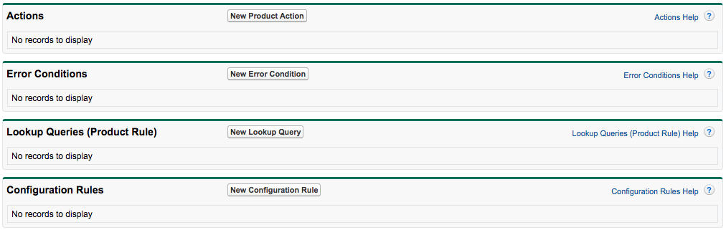
5. Set field values, then Save  
   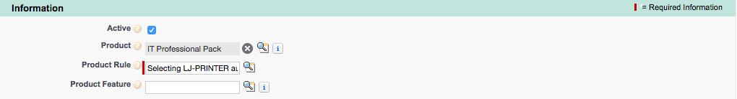
6. Navigate back to the Product Rule  
   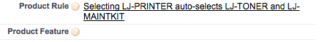
7. Click New Error Condition in Error Conditions  
   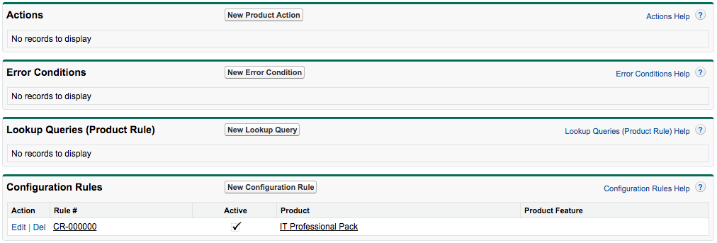
8. Open the Force.com Quote Access Menu, then click View Fields  
   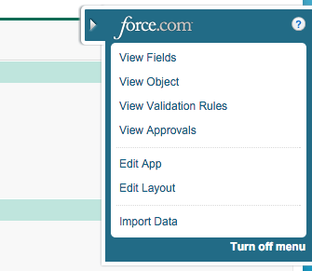
9. Click the Tested Field link  
   
10. Click New in Values  
    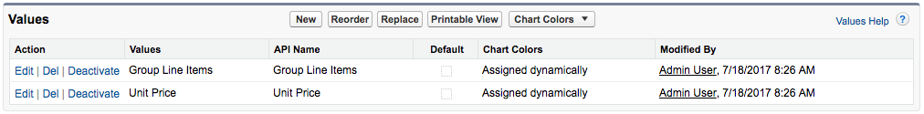
11. Enter API name of new Quote Line Field, then Save  
    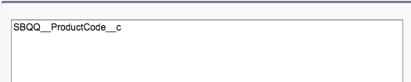
12. Click the Change link next to Tested Object  
    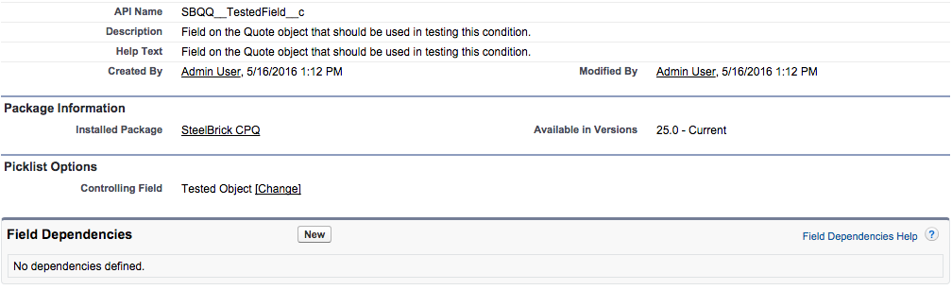
13. Double-click the Product Option API name under the Product Option column, then Save  
    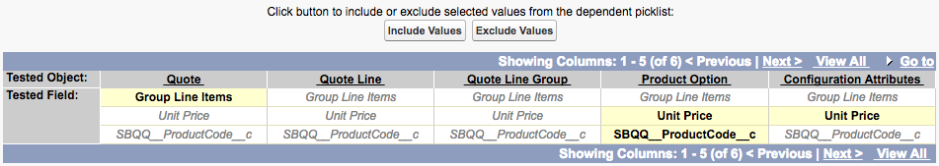
14. Click OK if a warning popup appears
15. Navigate back to the Error Condition and refresh the page
16. Set field values, then Save  
    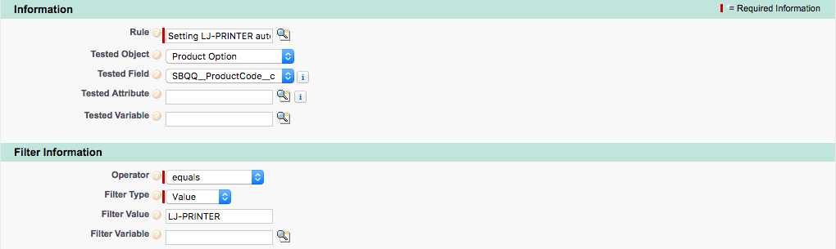
17. Navigate back to the Product Rule
18. Click New Product Action in Actions  
    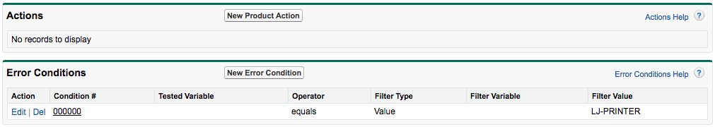
19. Set field values, then click Save & New  
    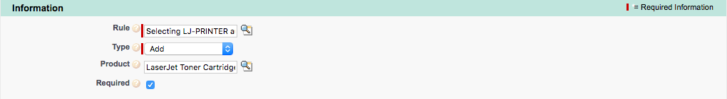
20. Set field values, then click Save  
    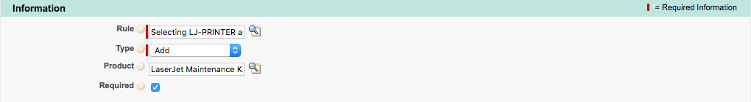
21. Navigate back to the ITPROPACK
22. Select the LJ-PRINTER Product Option  
    
23. Check the Apply Immediately checkbox, then Save  
    

# EX9: Toner Quantity Product Rule

Objective: Prevent the sales rep from saving the ITPROPACK configuration when they have included too few toners for the number of printers selected. Sales reps must sell at least as many toners as printers.

1. Navigate to Product Rule tab
2. Click New  
   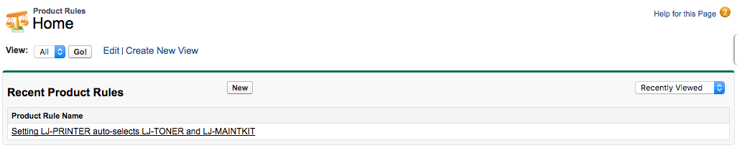
3. Set field values, then Save  
   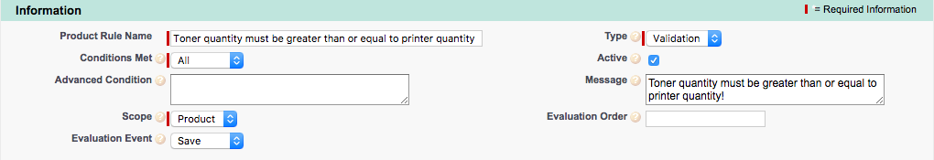
4. Click New Configuration Rule in Configuration Rules  
   
5. Set field values, then Save  
   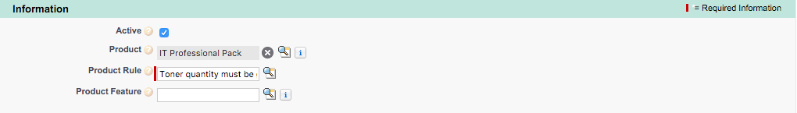
6. Navigate back to the Product Rule  
   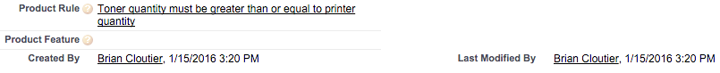
7. In a new tab, navigate to Summary Variables
8. Click New  
   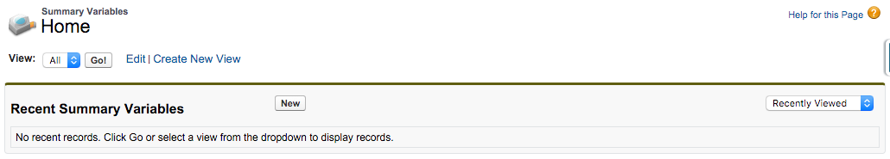
9. Set field values, then click Save & New  
   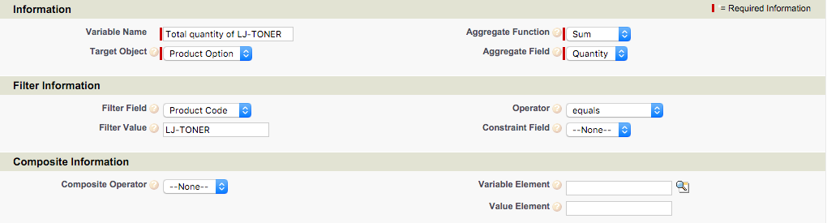
10. Set field values, then Save  
    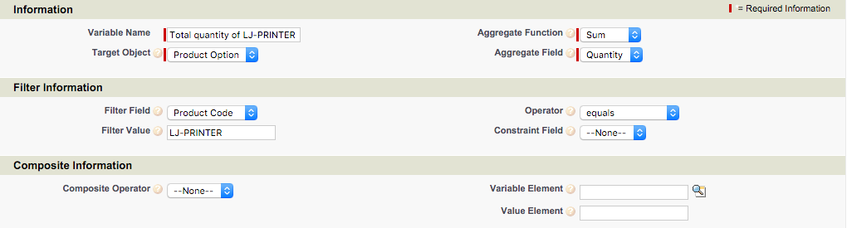
11. Navigate back to the incomplete Product Rule tab
12. Click New Error Condition in Error Conditions  
    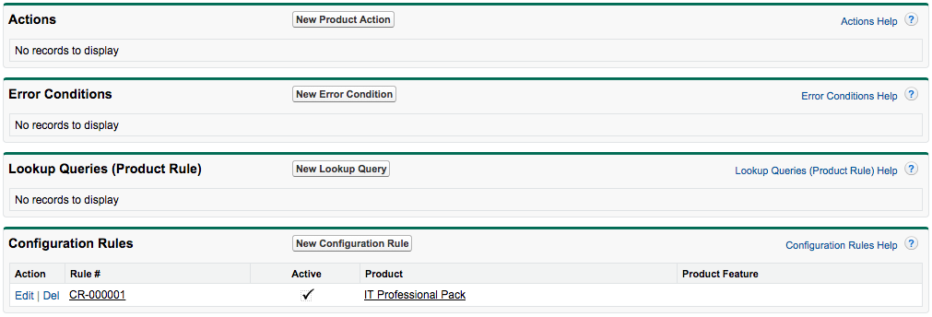
13. Set field values, then Save

# EX10: Create Configuration Attributes

Objective: Create a Location field that is visible when configuring the ITPROPACK. The values gathered by the configuration attribute will be used to drive logic in EX11, EX12, and EX14, but will also be saved to the Quote Line record of each bundle for future reference.

1. Navigate to Setup | Create | Objects | Product Option
2. Click New in Custom Fields & Relationships  
   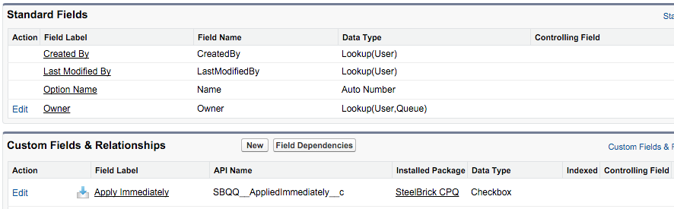
3. Choose Picklist then click Next  
   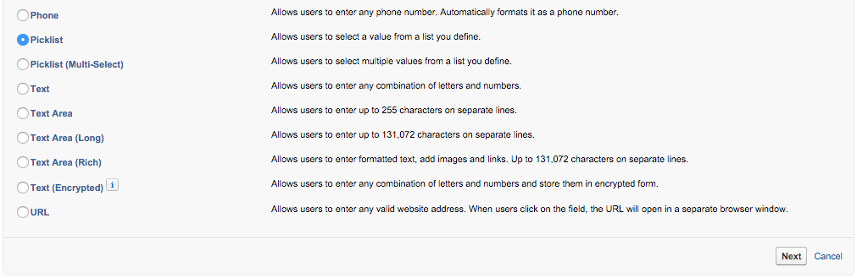
4. Set field values, click Next, Next, then click Save  
   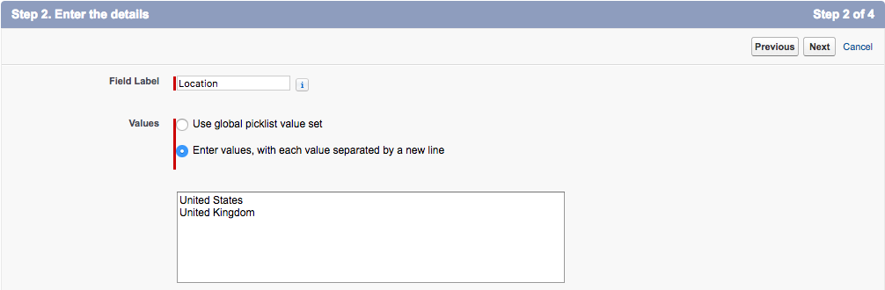
5. Navigate to the ITPROPACK product
6. Click New Configuration Attribute in the Configuration Attributes related list  
   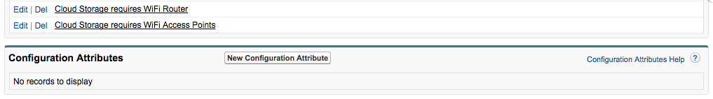
7. Open the Force.com Quick Access Menu, then click View Fields  
   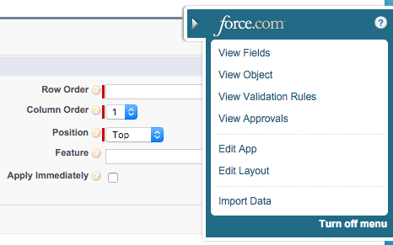
8. Click the Target Field link  
   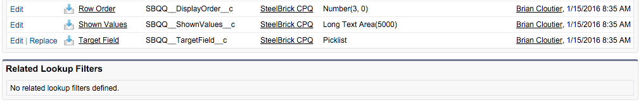
9. Click New in Values  
   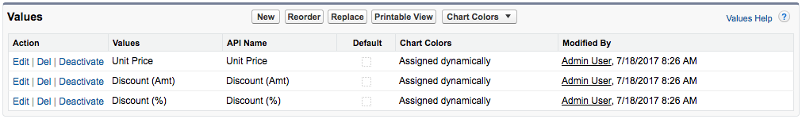
10. Enter API name of new Product Option Fields, then Save  
    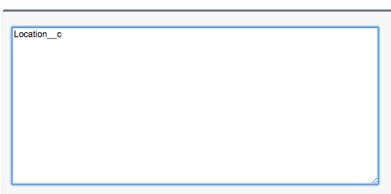
11. Return to the original Configuration Attribute tab and refresh the page
12. Set field values, then Save  
    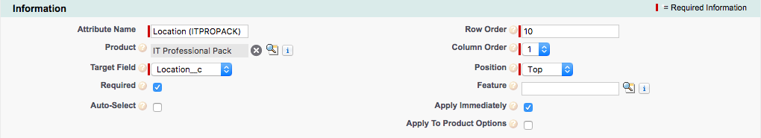
13. Navigate to Setup | Create | Objects | Quote Line
14. Click New in Custom Fields & Relationships  
    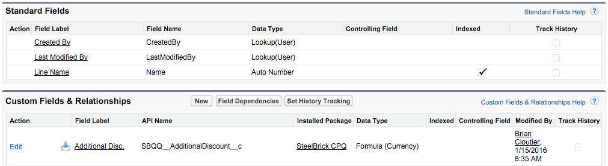
15. Choose Picklist then click Next  
    
16. Set field values, click Next, Next, then click Save  
    
17. Choose Picklist then click Next  
    

# EX11: US Items Product Rule

Objective: Simplify the ITPROPACK configuration process by removing the UK Keyboard and A4-sized paper options should the sales rep choose United States for the Location configuration attribute.

1. Navigate to Product Rule tab
2. Click New  
   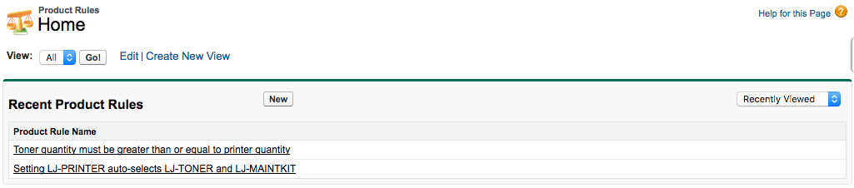
3. Set field values, then Save  
   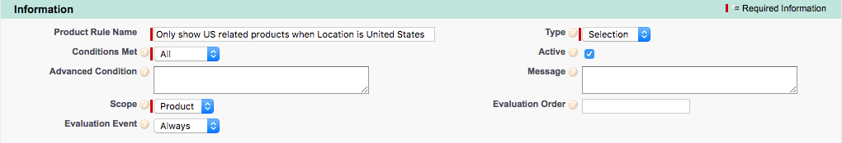
4. Click New Configuration Rule in Configuration Rules  
   
5. Set field values, then Save  
   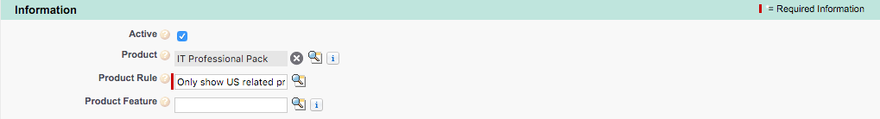
6. Navigate back to the Product Rule  
   
7. Click New Error Condition in Error Conditions  
   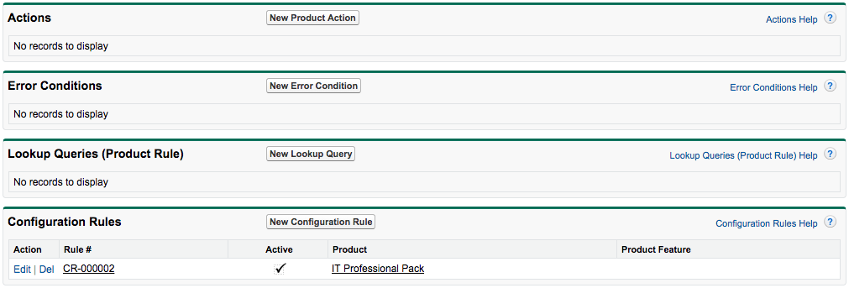
8. Open the Force.com Quick Access Menu, then click View Fields  
   
9. Click the Tested Field link  
   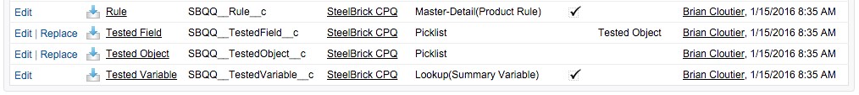
10. Click New in Values  
    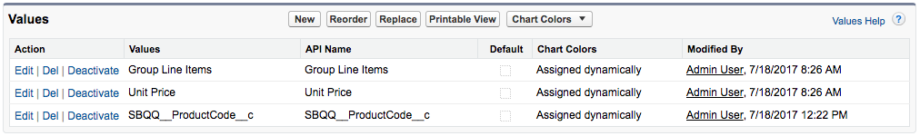
11. Enter API name of the Product Option Field used for the configuration attribute, then Save  
    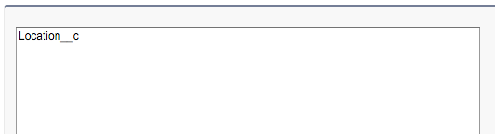
12. Click the Change link next to Tested Object  
    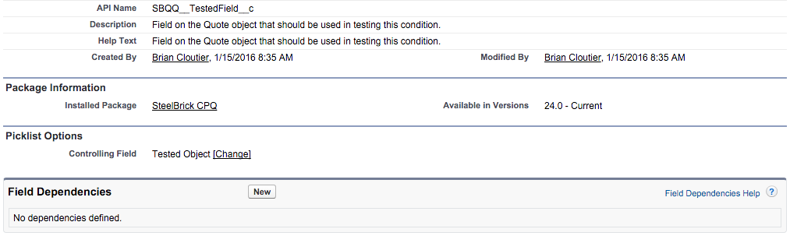
13. Double-click the Location API name Location__c under the Configurable Attributes column, then Save  
    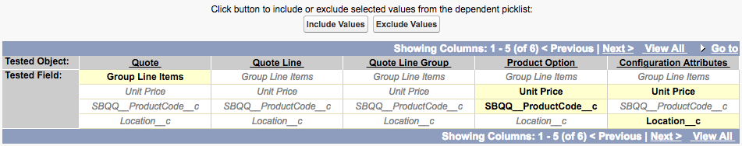
14. Click OK if a warning popup appears
15. Return to the original Error Condition tab and refresh the page
16. Set field values, then Save  
    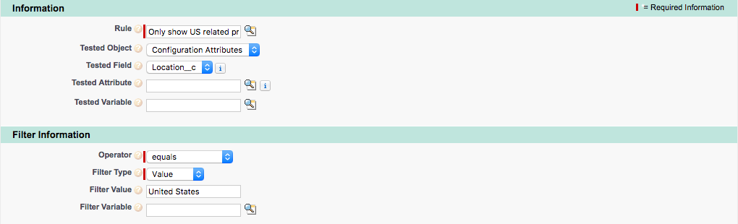
17. Navigate back to the Product Rule
18. Click New Product Action in Actions  
    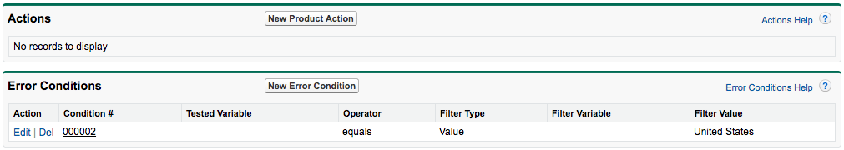
19. Set field values, then click Save & New  
    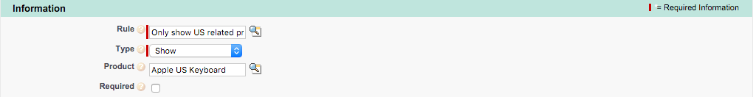
20. Set field values, then click Save & New  
    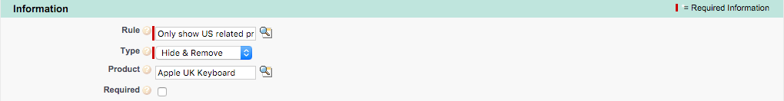
21. Set field values, then click Save & New  
    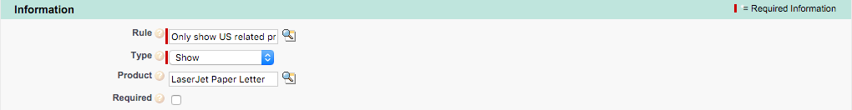
22. Set field values, then Save  
    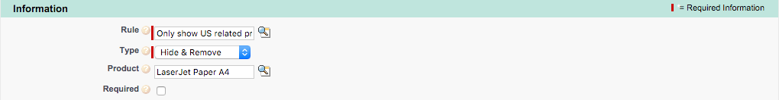

# EX12: UK Items Product Rule

Objective: Clone and modify the US Items Product Rule to remove the US Keyboard and Letter-sized paper options should the sales rep choose United Kingdom for the Location configuration attribute.

1. Navigate to Product Rule tab
2. Click the link for the Only Show US Products rule  
   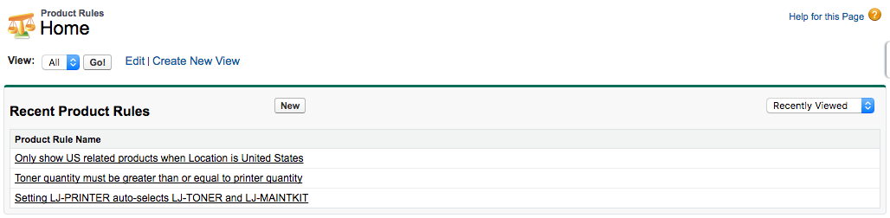
3. Click Clone with Related  
   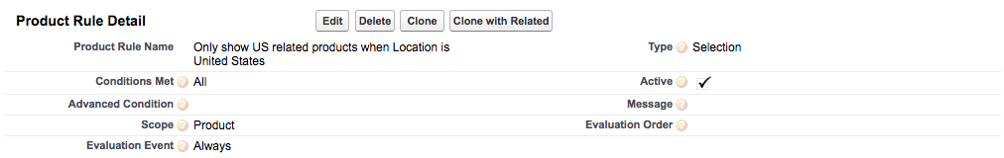
4. Click Clone  
   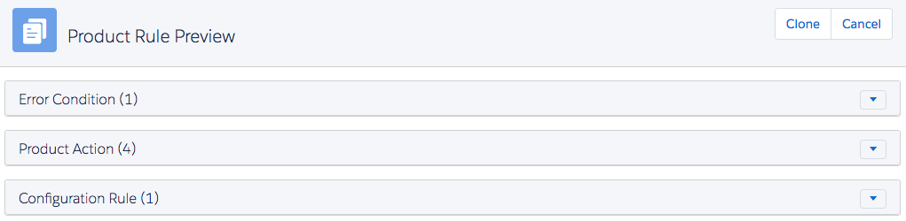
5. Update field value, then Save  
   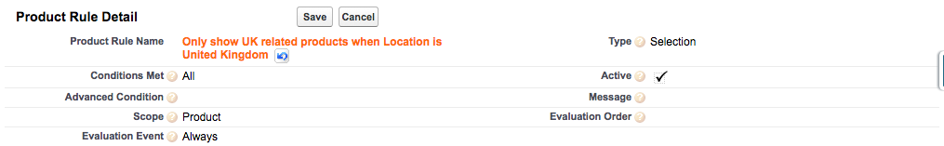
6. Click the Edit link for the Error Condition  
   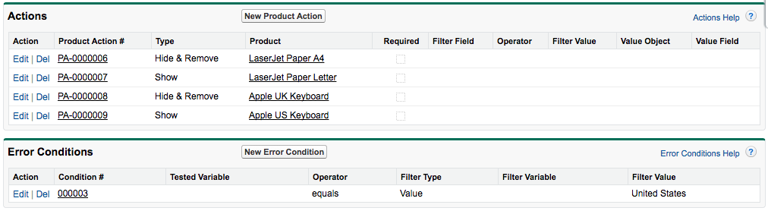
7. Update field value, then Save  
   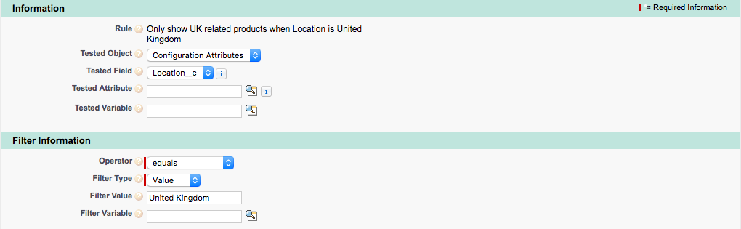
8. Click the Edit link for the first Product Action  
   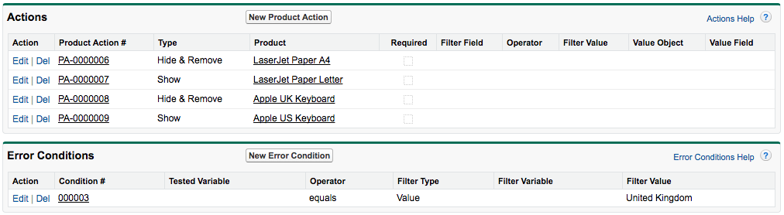
9. Update field value, then Save  
   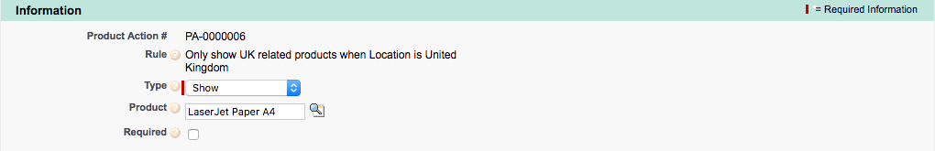

Repeat steps 8-9 for the remaining Product Actions, switching Hide & Remove to Show, and vice versa

# EX16: Hardware Products Custom Action

Objective: Create a button in the Quote Line Editor that when clicked, will only show products from the Hardware product family in the Product Selection screen.

1. Navigate to Custom Actions tab
2. Click New  
   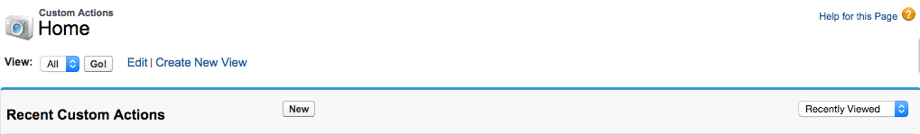
3. Open the Force.com Quick Access Menu, then click View Fields  
   
4. Click the Label link  
   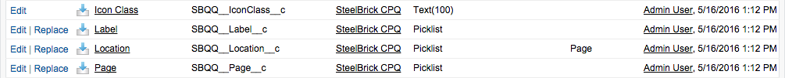
5. Click New in Values  
   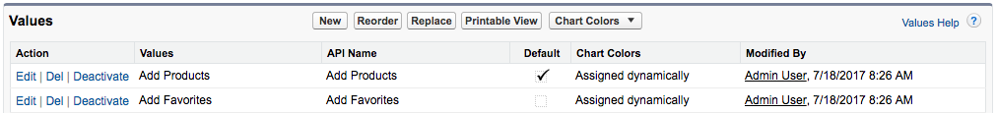
6. Enter Add Hardware, then Save  
   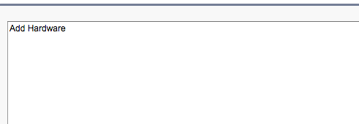
7. Return to the original Custom Action tab and refresh the page
8. Set field values, then Save  
   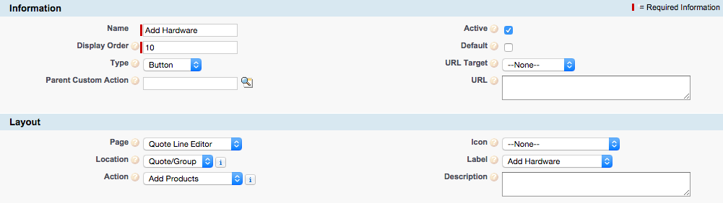
9. Click New Search Filter in Search Filters  
   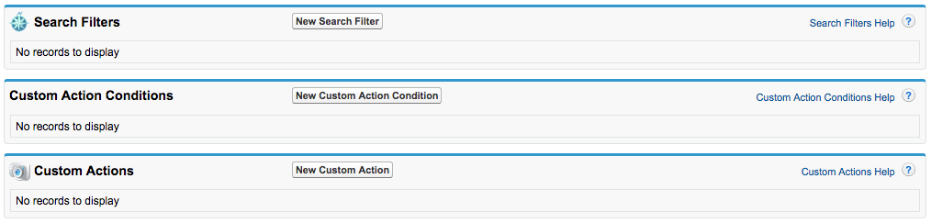
10. Set field values  
    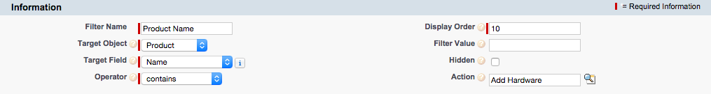
11. Click Save & New
12. Set field values  
    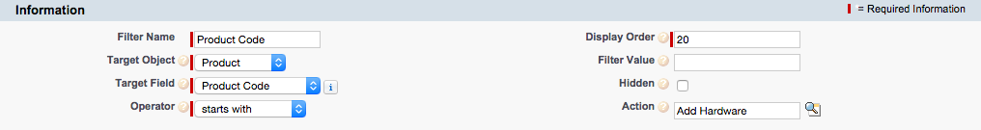
13. Click Save & New
14. Set field values, then Save  
    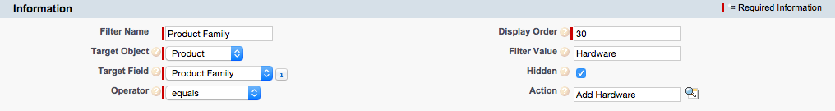

# EX20: Guided Selling

Objective: Create a guided selling process to assist the sales rep in selecting the appropriate IT Pack based on responses to three simple questions that appear on the Product Selection page.

1. Navigate to a Product and open the Force.com Quick Access Menu, then click View Fields  
   
2. Click New in Custom Fields & Relationships  
   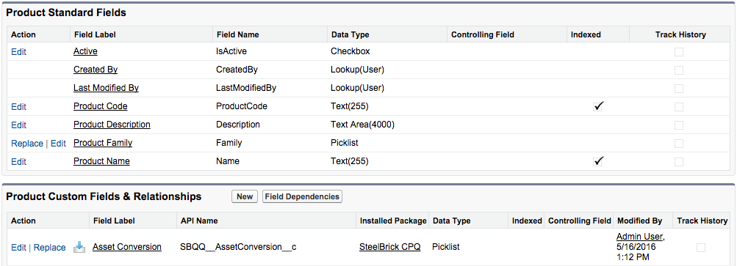
3. Choose Picklist then click Next  
   
4. Set field values, then click Next, Next, Save  
   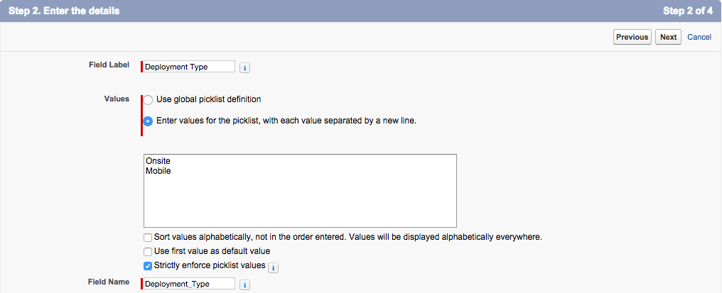
5. Click New in Custom Fields & Relationships  
   
6. Choose Picklist then click Next  
   
7. Set field values, then click Next, Next, Save  
   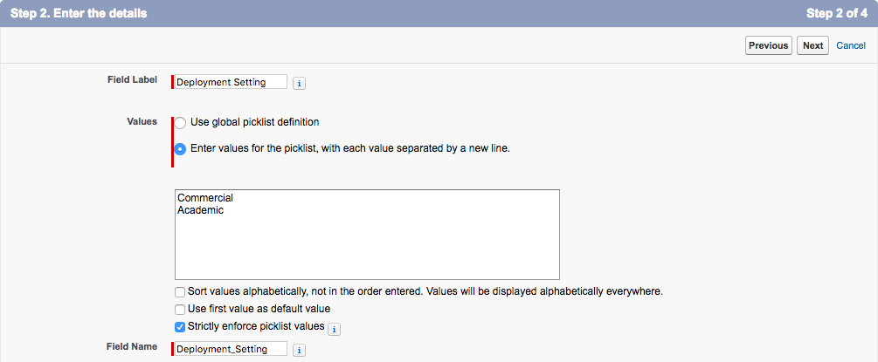
8. Click New in Custom Fields & Relationships  
   
9. Choose Picklist (Multi-Select) then click Next  
   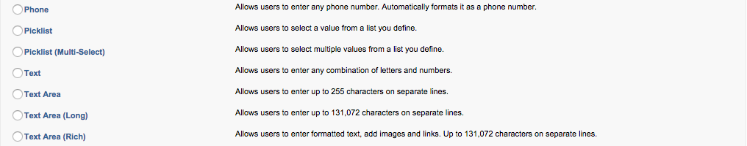
10. Set field values, then click Next, Next, Save  
    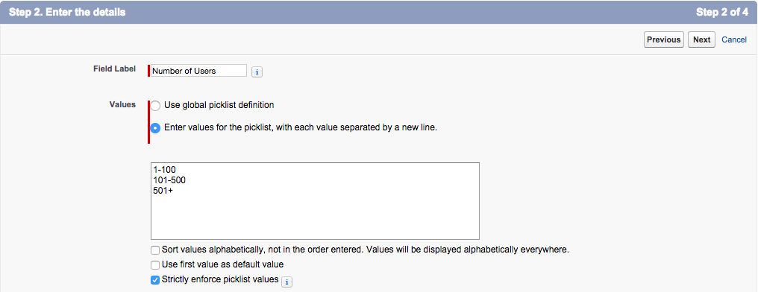
11. Open the ITPROPACK and set fields, then Save  
    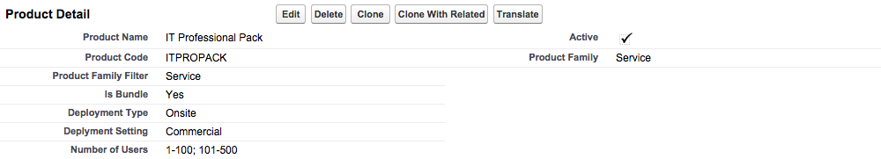
12. Set remaining product fields per table:

| Product | Deployment Type | Deployment Setting | Number of Users |
| --- | --- | --- | --- |
| IT Pro Pack | Onsite | Commercial | 1-100; 101-500 |
| IT Starter Pack | Onsite | Commercial | 1-100 |
| IT Mobile Pack | Mobile |  |  |
| IT Corporate Pack | Onsite | Commercial | 1-100; 101-500;  501+ |
| IT Education Pack | Onsite | Academic |  |

1. Navigate to Setup | Create | Objects | Process Input
2. Click the Product Field link  
   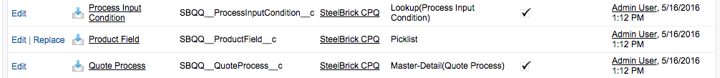
3. Click New in Values  
   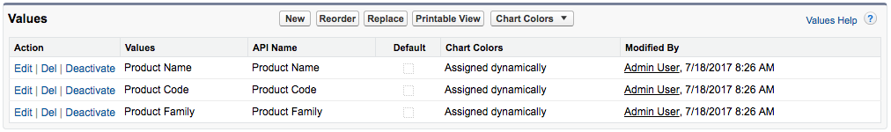
4. Enter the API Names of the three recently created Product Fields, then Save  
   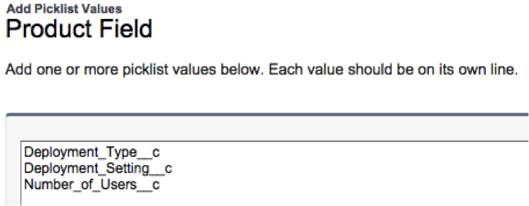
5. Navigate back to the Process Input Object  
   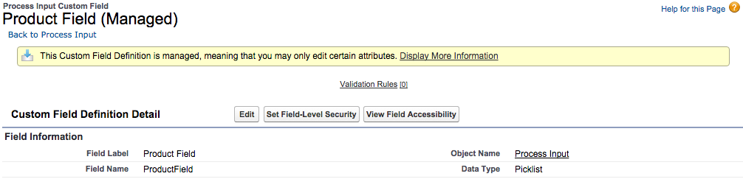
6. Click New in Custom Fields & Relationships  
   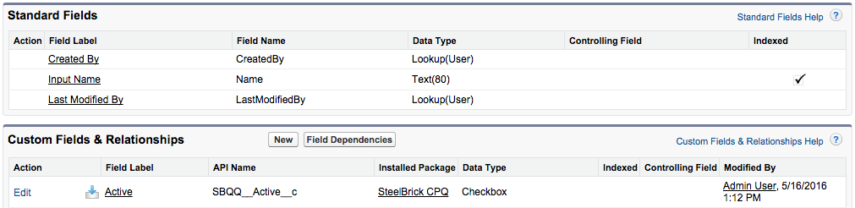
7. Choose Picklist then click Next  
   
8. Set field values then click Next, Next  
   
9. Uncheck the Add Field Checkbox, then click Save & New  
   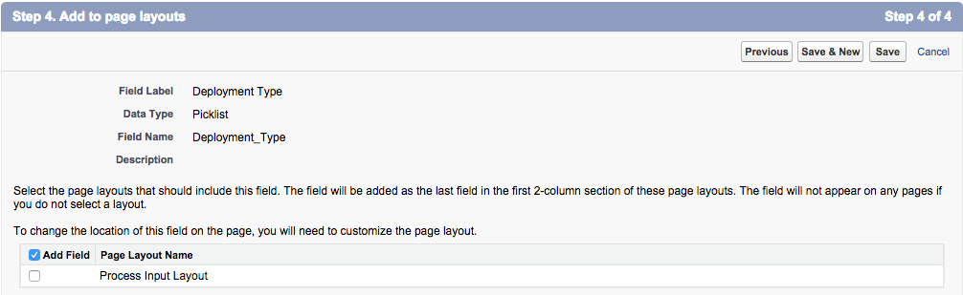
10. Choose Picklist then click Next  
    
11. Set field values then click Next, Next  
    
12. Uncheck the Add Field Checkbox, then click Save & New  
    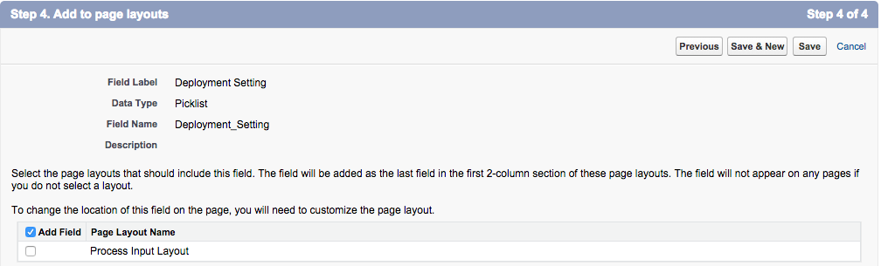
13. Choose Picklist then click Next  
    
14. Set field values, then click Next, Next  
    
15. Uncheck the Add Field Checkbox, then Save  
    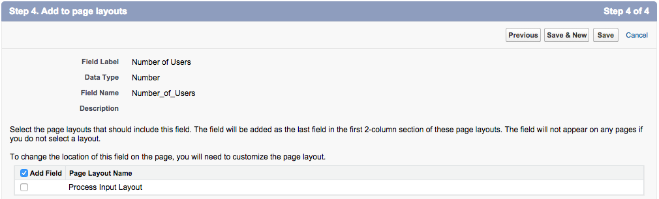
16. In a new tab open the Input Field link  
    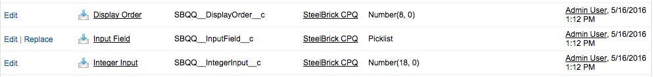
17. Click New in Values  
    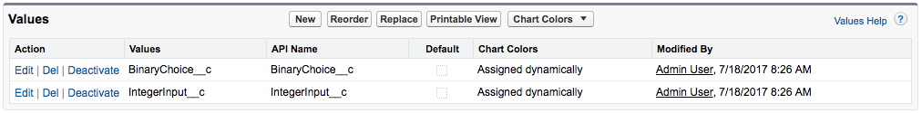
18. Enter the API names of the three fields created on the Process Input Object, then Save  
    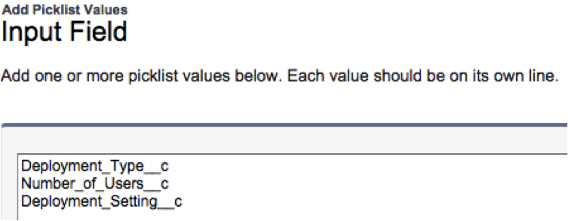
19. Navigate to Quote Processes tab
20. Click New  
    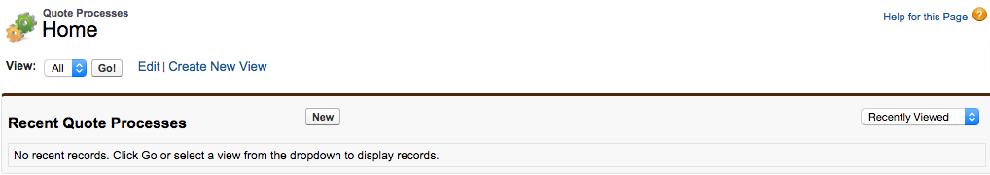
21. Set field values, then Save  
    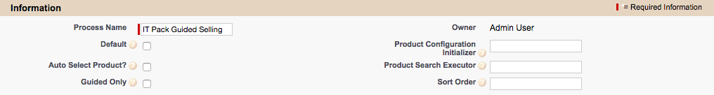
22. Click New Process Input in Process Inputs  
    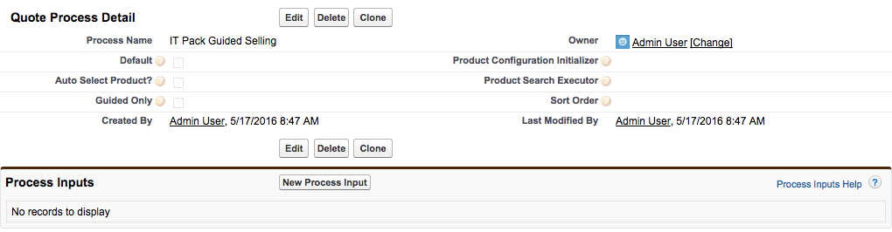
23. Set field values, then click Save & New  
    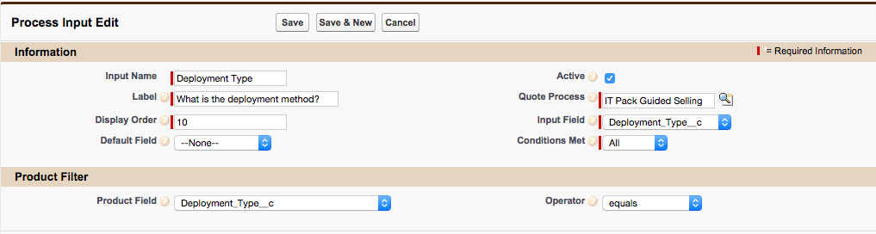
24. Set field values, then click Save & New  
    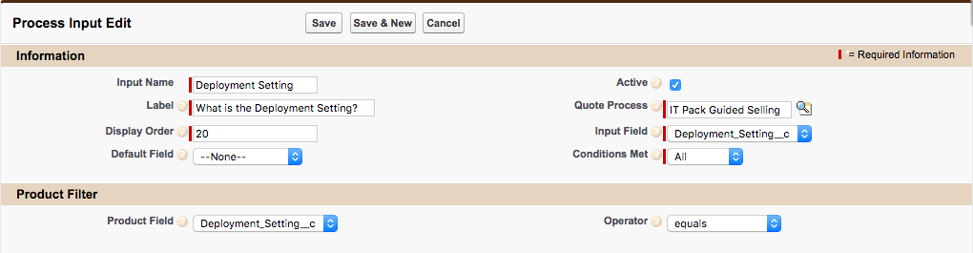
25. Set field values, then Save  
    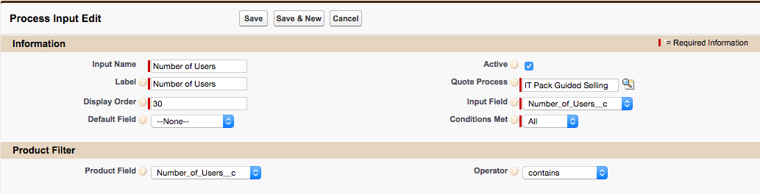
26. Navigate back to IT Pack Guided Selling Quote Process  
    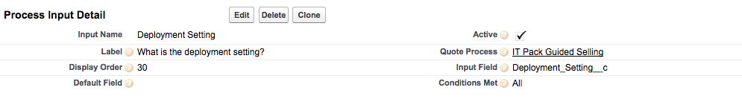
27. Click the Deployment Setting Process Input  
    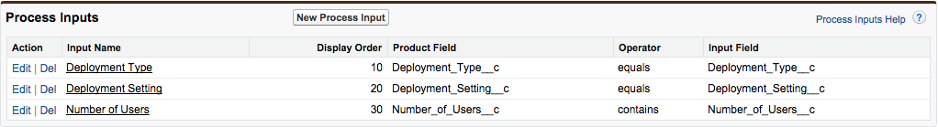
28. Click New Process Input Condition in Process Input Conditions  
    
29. Set field values, then Save  
    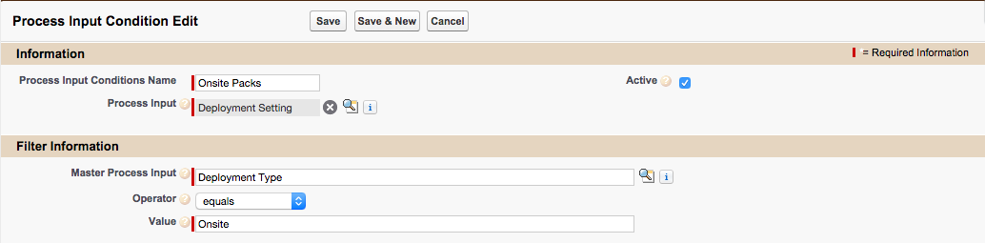
30. Navigate back to the IT Pack Guided Selling Quote Process  
    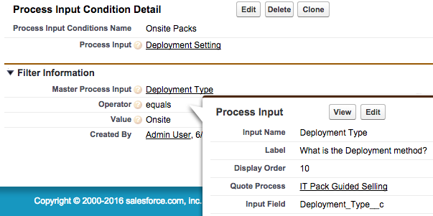
31. Click the Number of Users Process Input  
    
32. Click New Process Input Condition in Process Input Conditions  
    
33. Set field values, then Save  
    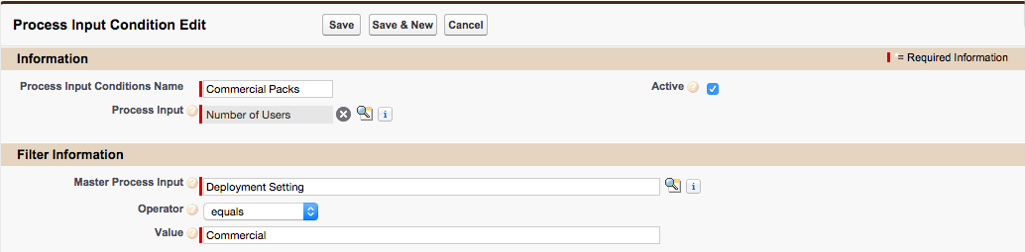
34. Navigate to the quote process and copy the Salesforce ID from the URL  
    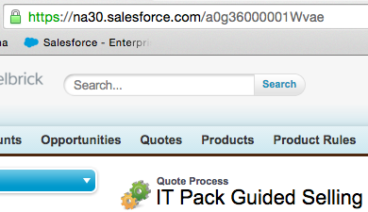
35. Navigate to a Quote
36. Paste the Salesforce ID into the Quote Process ID field on the Quote, then Save  
    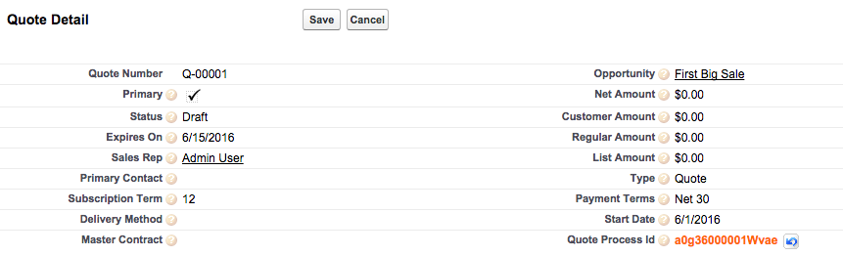

# 

# EX23: Create a Discount Schedule

Objective: Create a discount schedule so that the customer receives a discount for buying greater quantities of LaserJet paper, increasing the discount for every 10 purchased up to a limit.

1. Navigate to Discount Schedules tab
2. Click New  
   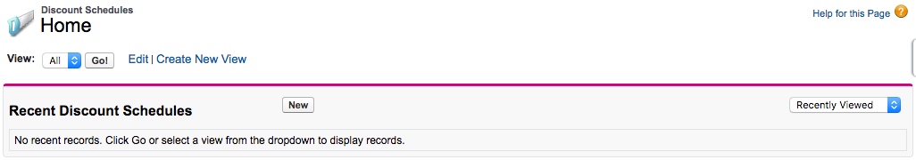
3. Set field values, then Save  
   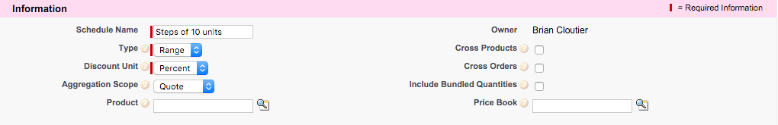
4. Set tiers, then Save  
   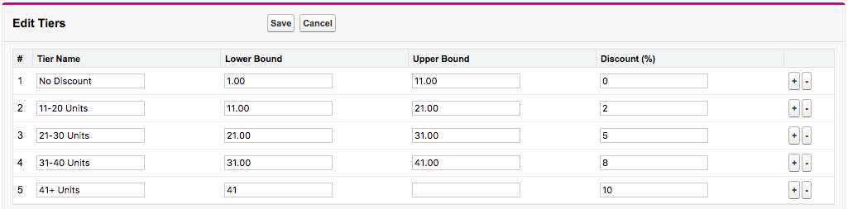
5. Navigate to the LJ-PAPERLETTER product
6. Set Discount Schedule, then Save  
   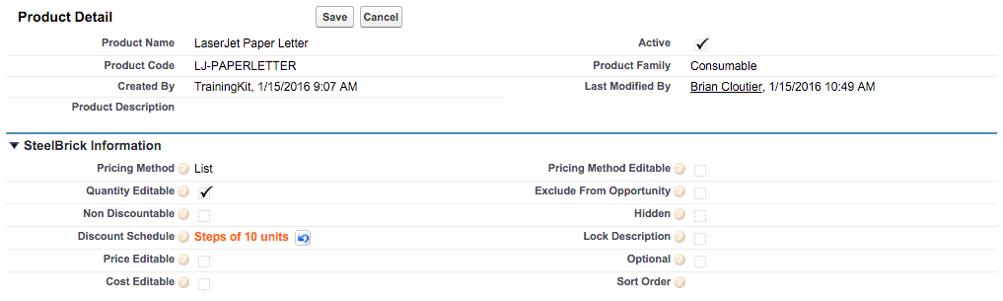

# EX24: Block Pricing

Objective: Create block prices for the Toner Recycling product so that recycling any quantity between 1 and 20 results in a flat price; any quantity between 21-50 a different flat price; and any quantity above 50 an over price of $1 per unit.

1. Navigate to the TONERRECYCLE product
2. Set Pricing Method, then Save  
   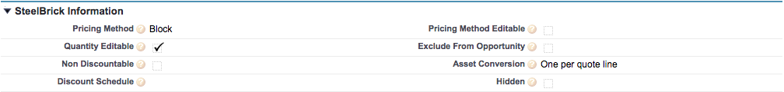
3. Click New Block Price in Block Prices  
   
4. Set field values, then click Save & New  
   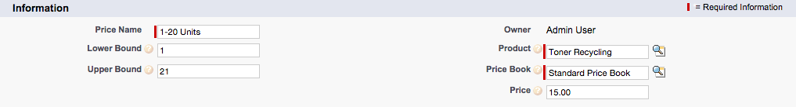
5. Set field values, then click Save & New  
   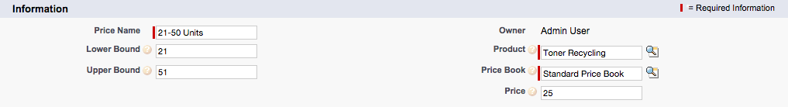
6. Open the Force.com Quick Access Menu, then click View Fields  
   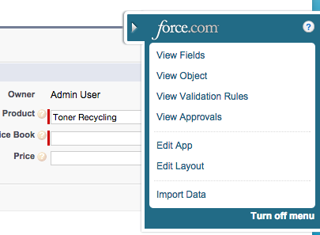
7. Click New in Custom Fields & Relationships  
   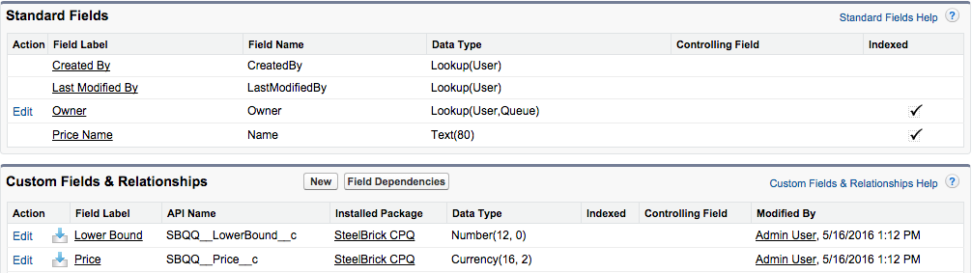
8. Choose Currency then click Next  
   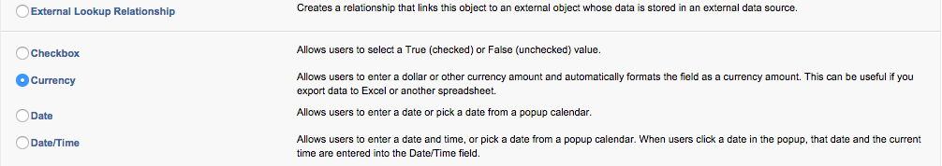
9. Set field values, then click Next, Next, Save  
   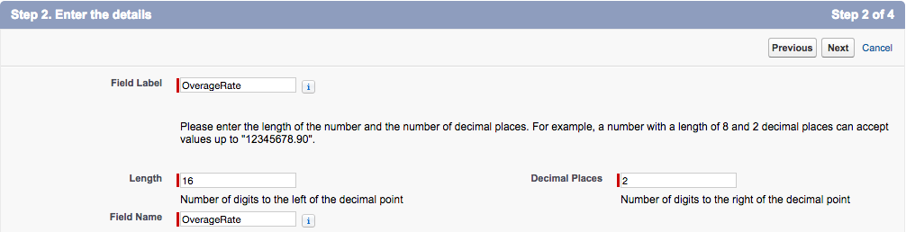
10. Return to the Block Prices tab and refresh the page
11. Set field values, then Save  
    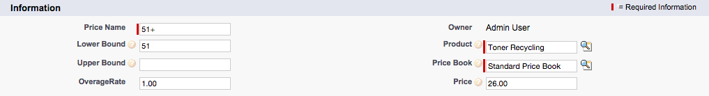

# EX25: Multi-Dimensional Quoting

Objective: Allow sales reps to sell the Cloud Storage subscription product in yearly segments, where each segment may have a unique quantity, discount, and uplift. Also, include a one-time Activation fee to the Cloud Storage product.

1. Navigate to the CLOUDSTORAGE product
2. Update field value, then Save  
   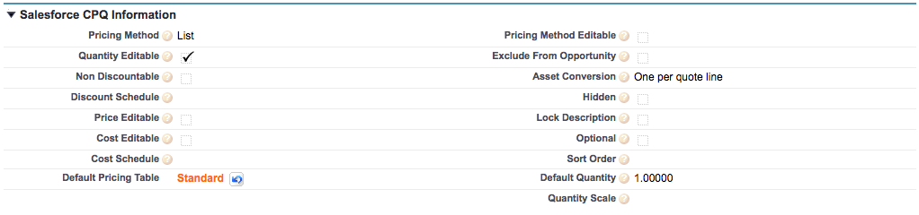
3. Click New Price Dimension in Price Dimensions  
   
4. Set field value, then click Save & New  
   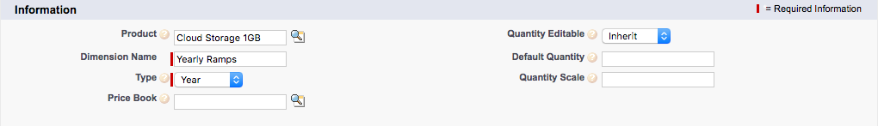
5. Set field values, then Save  
   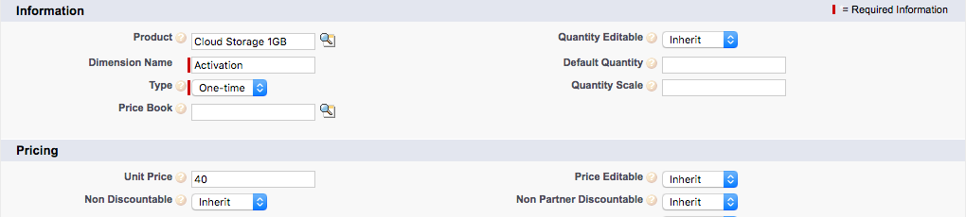

# EX26: Maintenance Kit Price Rule

Objective: Create a rule that automatically updates the quantity of the LaserJet maintenance kit product to exactly 2 times the quantity of printers.

1. Navigate to the Price Rules tab
2. Click New  
   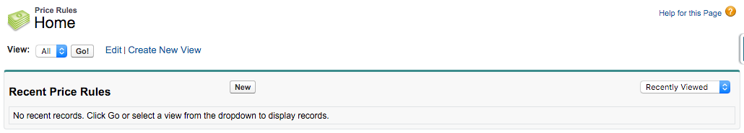
3. Set field values, then Save  
   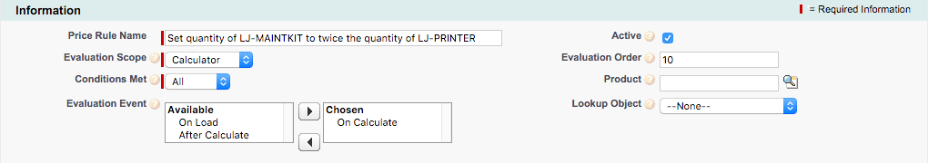
4. Click New Price Condition in Price Conditions  
   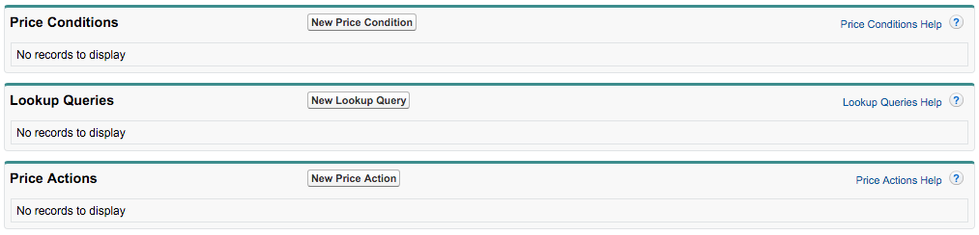
5. Set field values, then Save  
   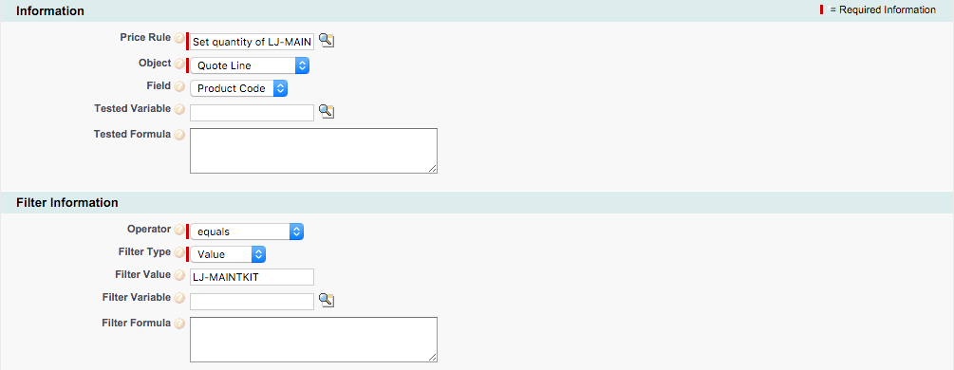
6. Navigate back to the Price Rule
7. Click New Price Action in Price Actions  
   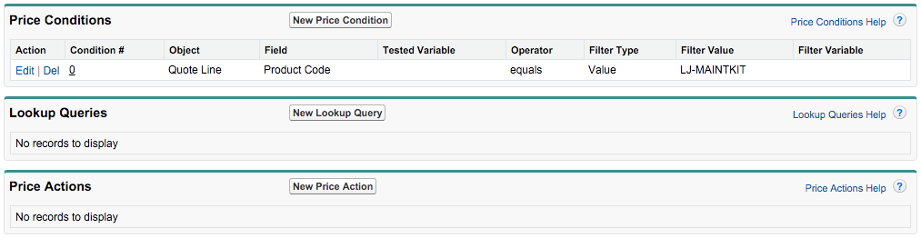
8. Open the Force.com Quick Access Menu, then click View Fields  
   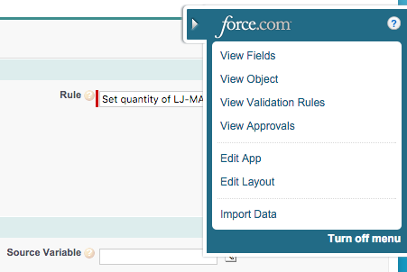
9. Click the Target Field link  
   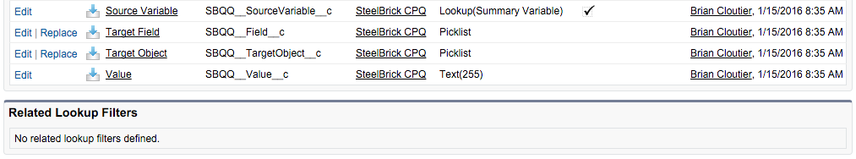
10. Click New in Values  
    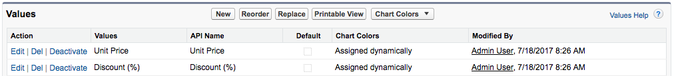
11. Enter API name of the Quote Line Quantity field, then Save  
    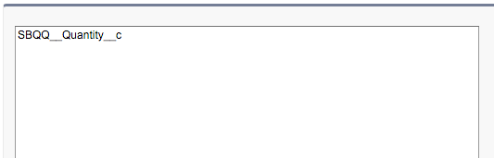
12. Return to the original Price Action tab and refresh the page
13. In a new tab, navigate to Summary Variables
14. Click New  
    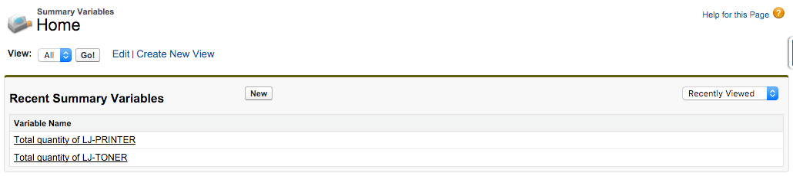
15. Set field values, then Save  
    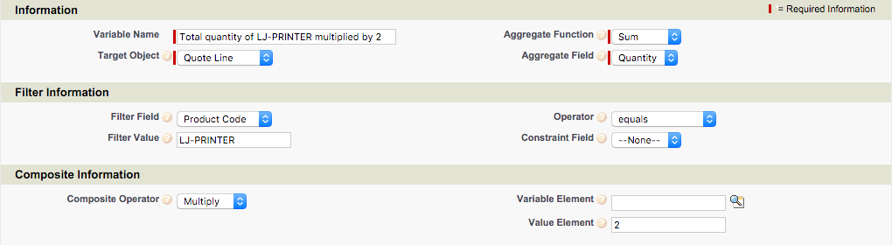
16. Return to the original Price Action tab
17. Set field values, then Save  
    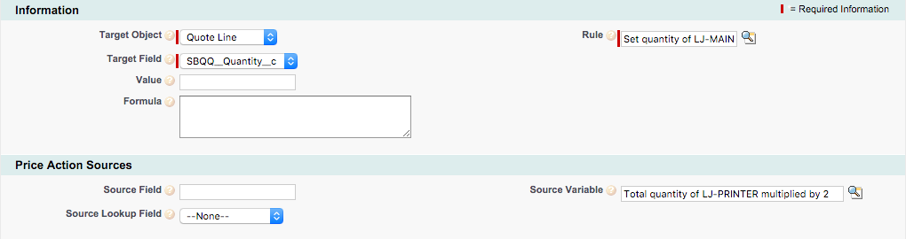

# EX27: WiFi Access Point Price Rule

Objective: Create a rule that automatically sets the quantity of WiFi Access Points to ensure that 1 access point is included for every 12 MacBook Pros, and that fractional quantities are not used.

1. Navigate to the Price Rules tab
2. Click New  
   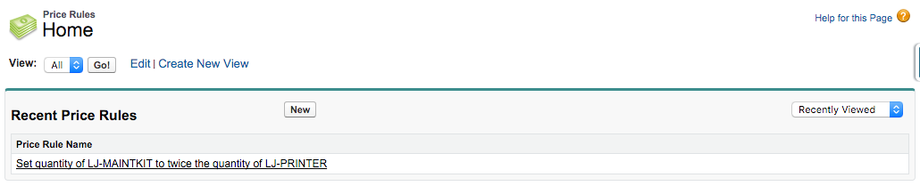
3. Set field values, then Save  
   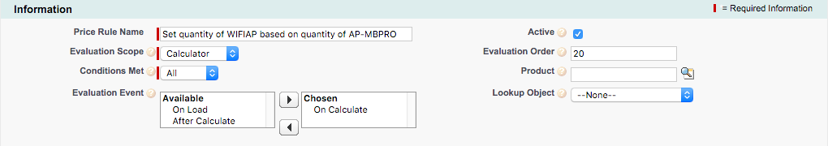
4. Click New Price Condition in Price Conditions  
   
5. Set field values, then Save  
   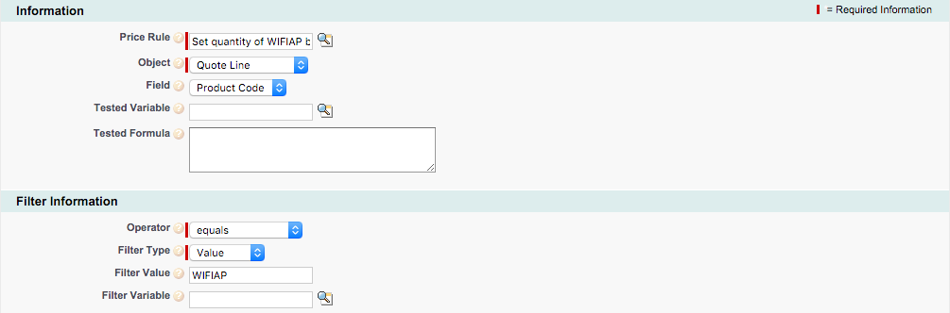
6. Navigate back to the Price Rule
7. Click New Price Action in Price Actions  
   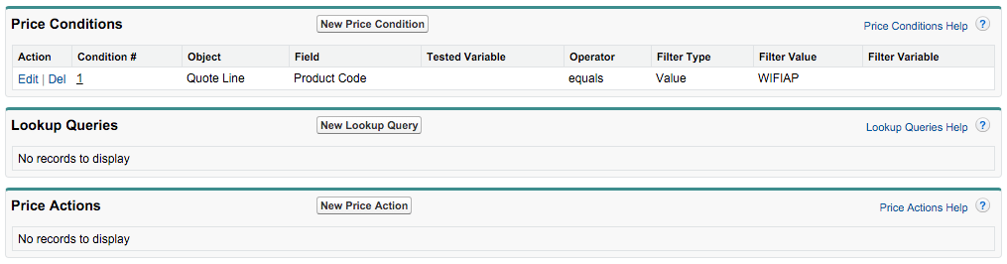
8. In a new tab, navigate to Summary Variables
9. Click New  
   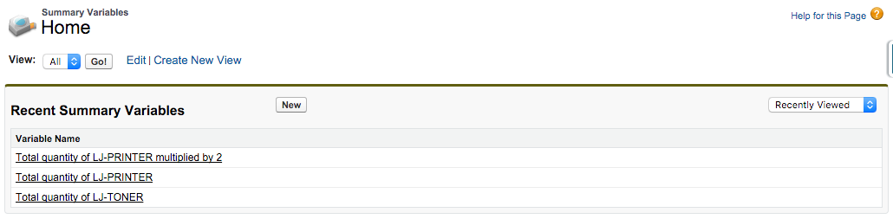
10. Set field values, then Save  
    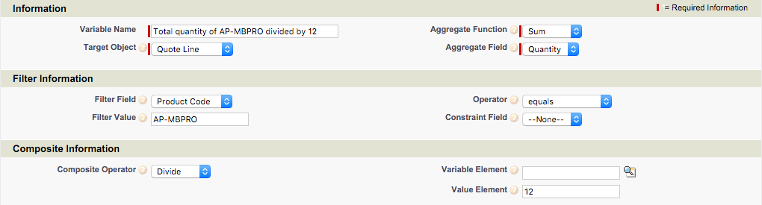
11. Return to the original Price Action tab
12. Set field values, then click Save & New  
    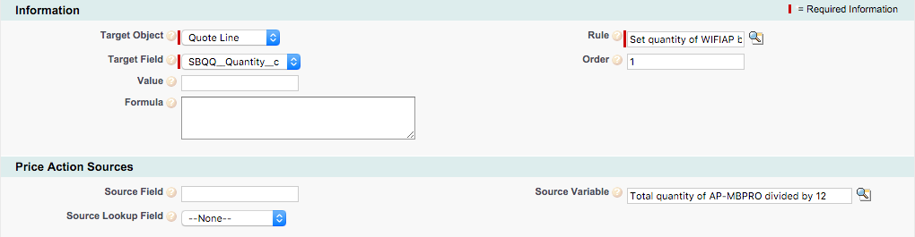
13. Set field values, then Save  
    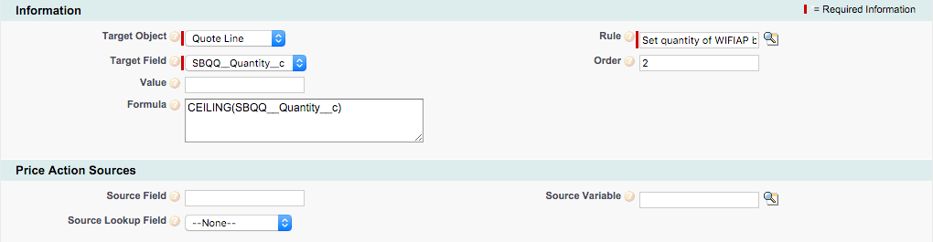

# EX28: Total Cost of Hardware Price Rule

Objective: Create a rule to automatically update a custom quote-level field to represent the total cost of only products in the Hardware product family.

1. Navigate to Setup | Create | Objects | Quote Line
2. Click New in Custom Fields & Relationships  
   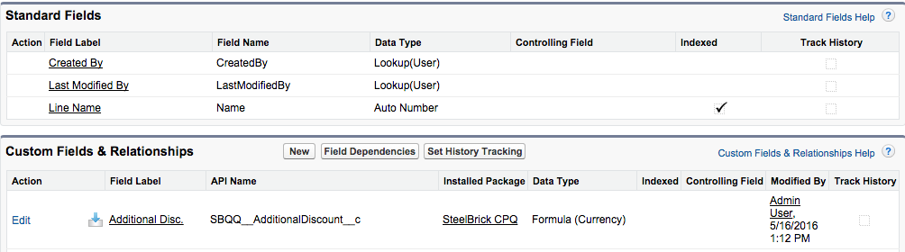
3. Choose Formula then click Next  
   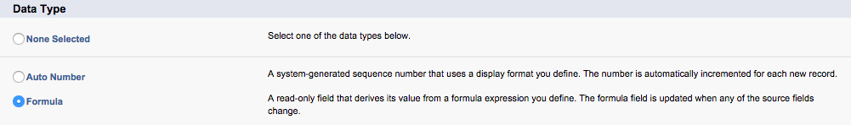
4. Set field values, then click Next  
   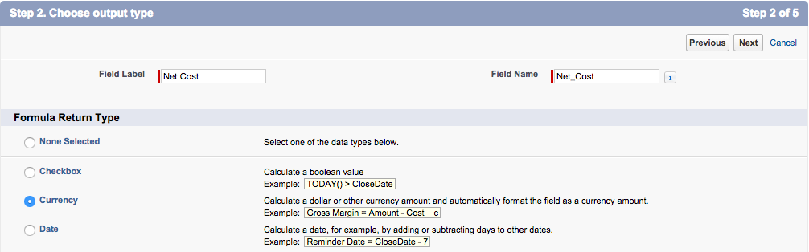
5. Set formula as described below, then click Next, Next, Save  
    SBQQ__Cost__r.SBQQ__UnitCost__c * SBQQ__Quantity__c
6. Navigate to Setup | Create | Objects | Quote
7. Click New in Custom Fields & Relationships  
   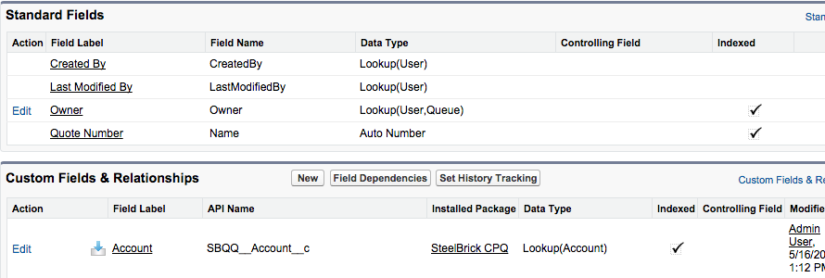
8. Choose Currency then click Next  
   
9. Set field values, then click Next, Next, Save  
   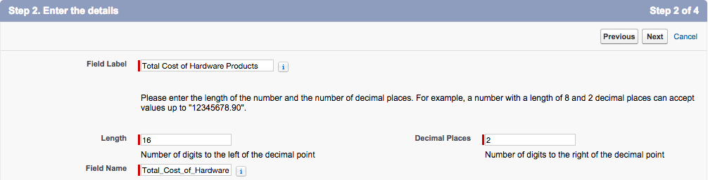
10. Navigate to the Price Rules tab
11. Click New  
    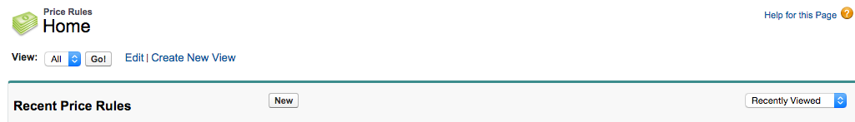
12. Set field values, then Save  
    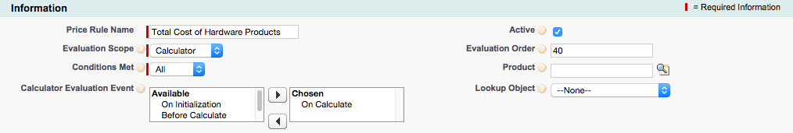
13. Click New Price Action in Price Actions  
    
14. Open the Force.com Quick Access Menu, then click View Fields  
    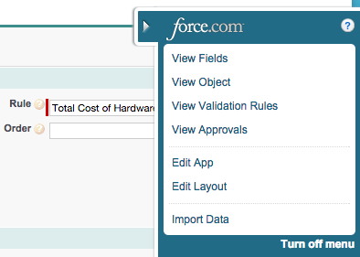
15. Click the Target Field link  
    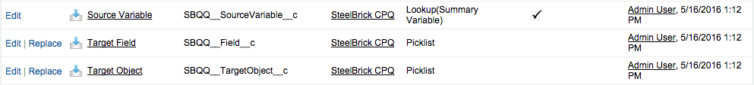
16. Click New in Values  
    
17. Enter API name of the new Quote Field, then Save  
    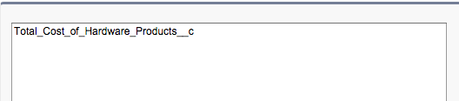
18. Return to the original Price Action tab and refresh the page
19. In a new tab, navigate to Summary Variables
20. Click New  
    
21. Open the Force.com Quick Access Menu, then click View Fields  
    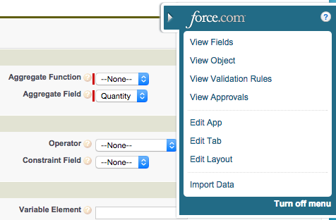
22. Click the Aggregate Field link  
    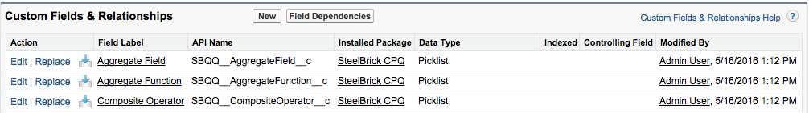
23. Click New in Values  
    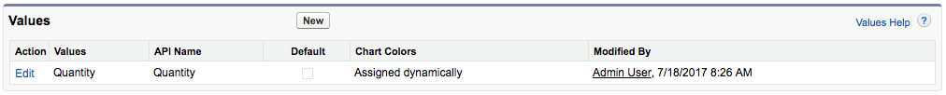
24. Enter API name of the new Quote Line Field, then Save  
    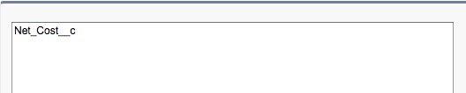
25. Return to the original Summary Variables tab and refresh the page
26. Set field values, then Save  
    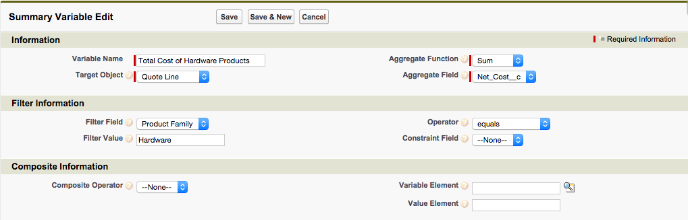
27. Return to the original Price Action tab
28. Set field values, then Save  
    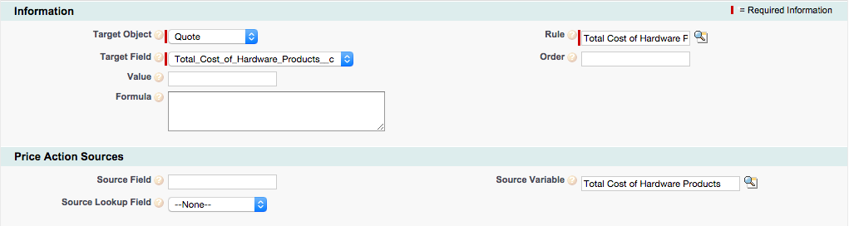

# EX29: Partner Discount Price Rule

Objective: Create a rule to automatically update the Partner Discount quote line field based on the custom Account field named Partner Level. The discount percent will be either 10, 20, or 30 for bronze, silver, or gold, respectively.

1. Navigate to an Account and open the Force.com Quick Access Menu, then click View Fields  
   
2. Click New in Custom Fields & Relationships  
   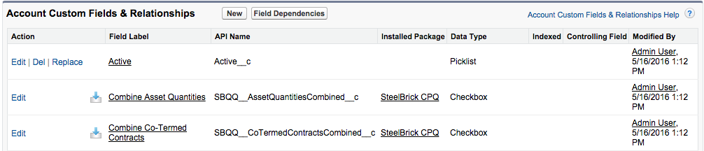
3. Choose Picklist then click Next  
   
4. Set field values, add Picklist values, then click Next, Next, Save  
   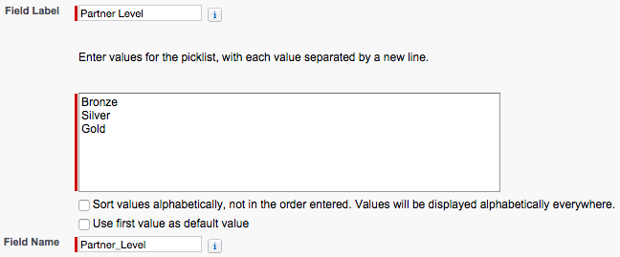
5. Navigate to Setup | Create | Objects | Quote
6. Click New in Custom Fields & Relationships  
   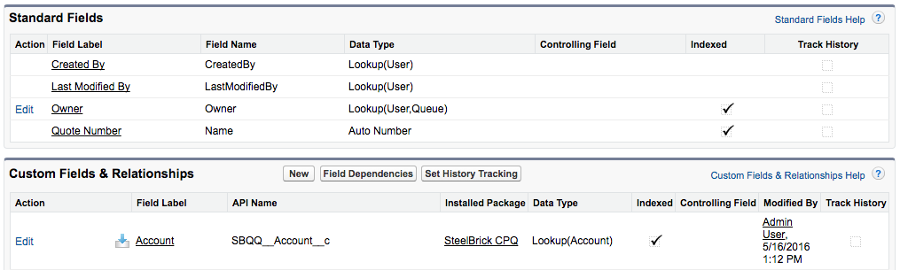
7. Choose Formula then click Next  
   
8. Set field values, then click Next  
   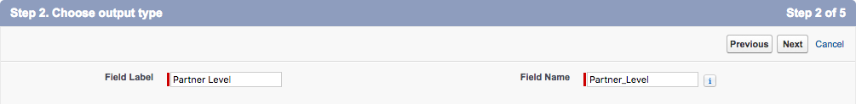  
   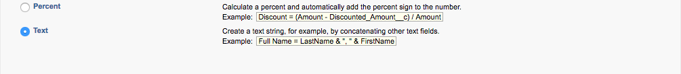
9. Set formula as described below, then click Next, Next, Save  
    TEXT(SBQQ__Account__r.Partner_Level__c)
10. Navigate to the Price Rules tab
11. Click New  
    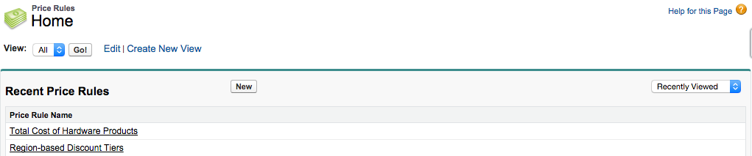
12. Set field values, then Save  
    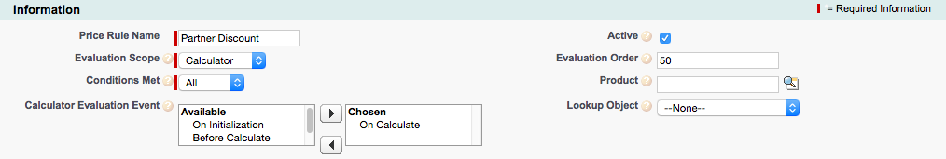
13. Click New Price Condition in Price Conditions  
    
14. Open the Force.com Quick Access Menu, then click View Fields  
    
15. Click the Field link  
    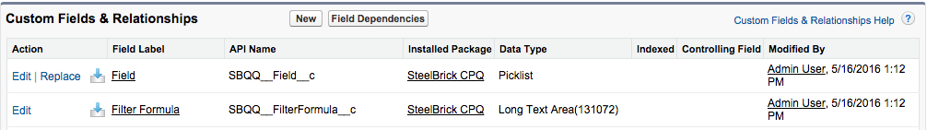
16. Click New in Values  
    
17. Enter API name of new Quote field, then Save  
    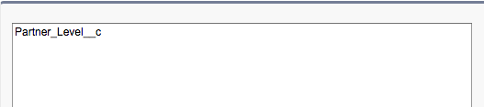
18. Return to the original Price Condition tab and refresh the page
19. Set field values, click Save  
    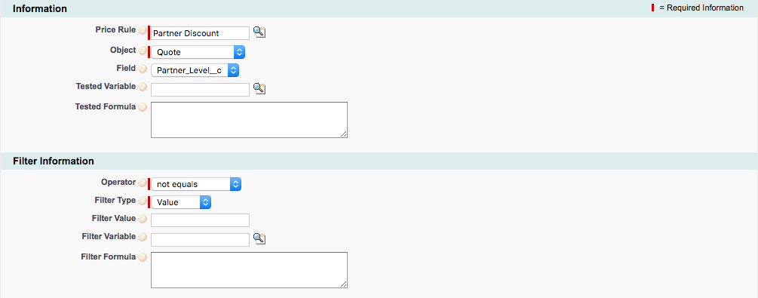
20. Navigate back to the Price Rule
21. Click New Price Action in Price Actions  
    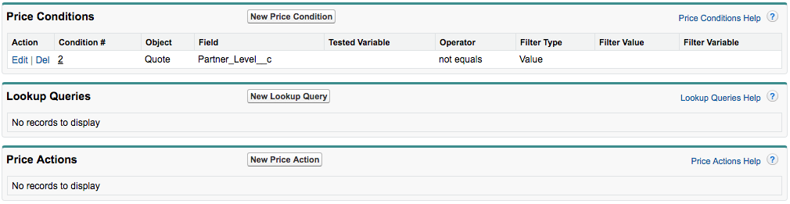
22. Open the Force.com Quick Access Menu, then click View Fields  
    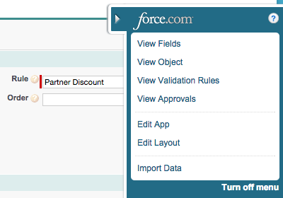
23. Click the Target Field link  
    
24. Click New in Values  
    
25. Enter API name of the Quote Line Partner Discount field, then Save  
    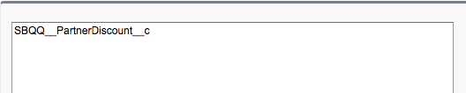
26. Return to the original Price Action tab and refresh the page
27. Set field values and formula body as described below, then Save  
    CASE(SBQQ__Quote__r.Partner_Level__c,"Bronze",10,"Silver",20,"Gold",30)  
    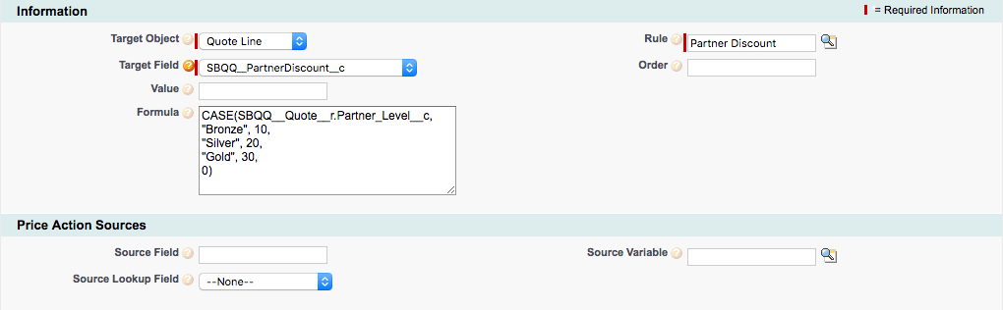

# EX30: Create a Lookup Object

Objective: Create a custom object to represent a discount matrix of possible partner discount and product family combinations, to be used in EX29.

1. Navigate to Setup | Create | Objects
2. Click New Custom Object  
   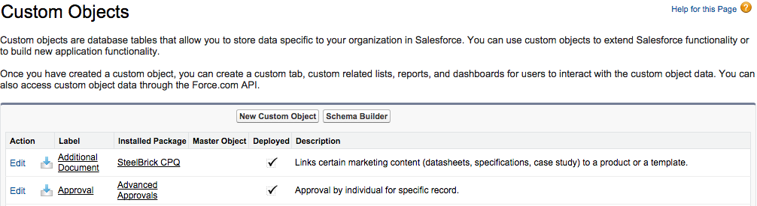
3. Set field values, then Save  
   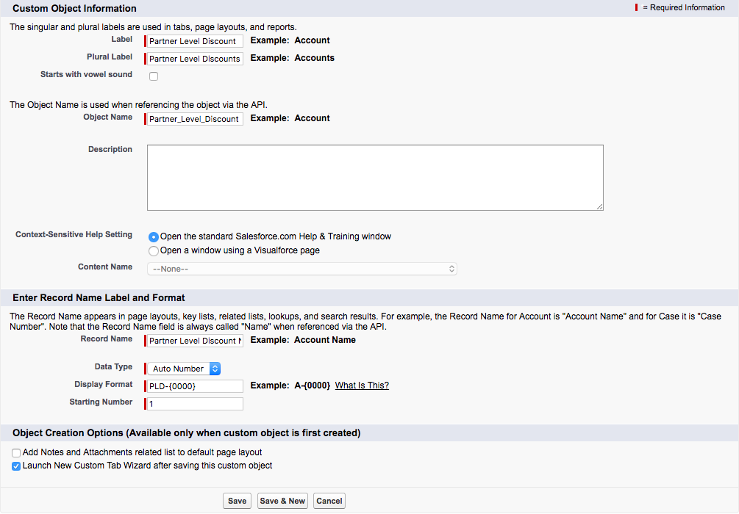
4. Set field values, then click Next, Next, Save  
   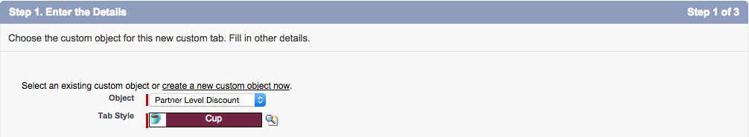
5. Click New in Custom Fields & Relationships  
   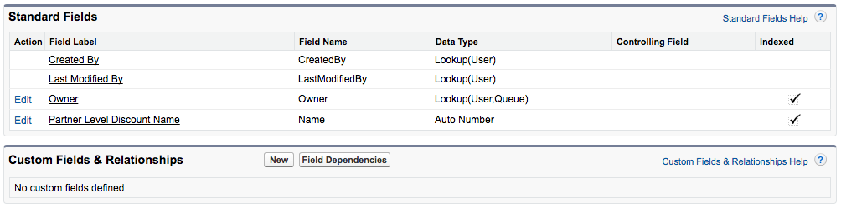
6. Choose Picklist then click Next  
   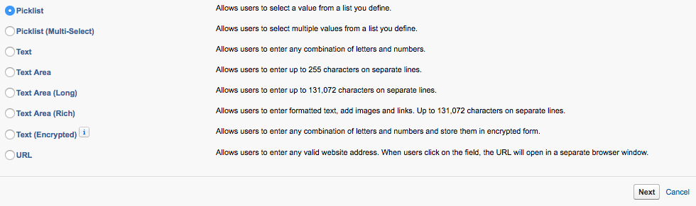
7. Set field values, click Next, Next, then click Save & New  
   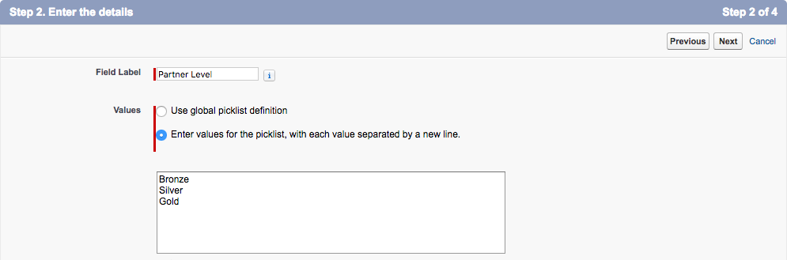
8. Choose Picklist then click Next  
   
9. Set field values, click Next, Next, then click Save & New  
   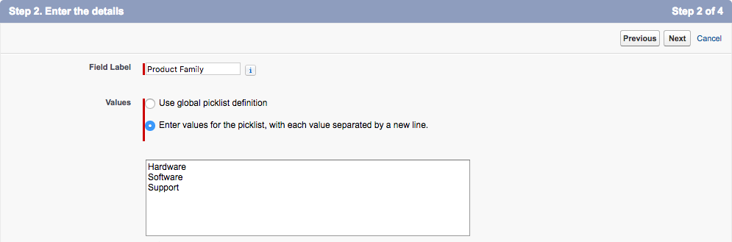
10. Choose Number then click Next  
    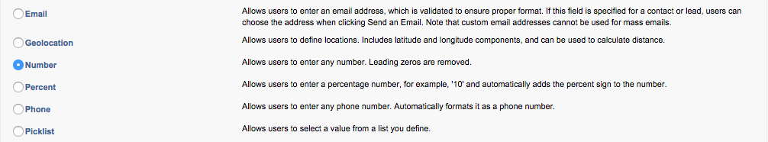
11. Set field values, then click Next, Next, Save  
    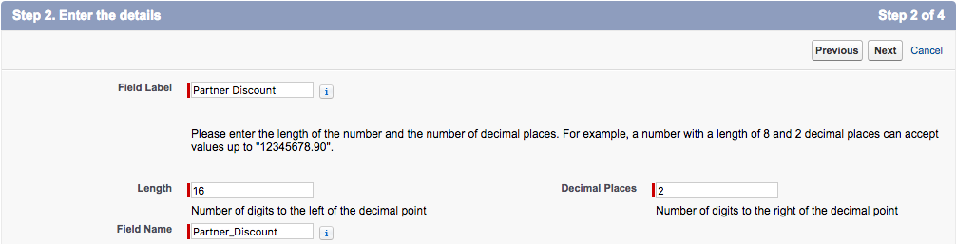
12. Navigate to Partner Level Discount tab
13. Click New  
    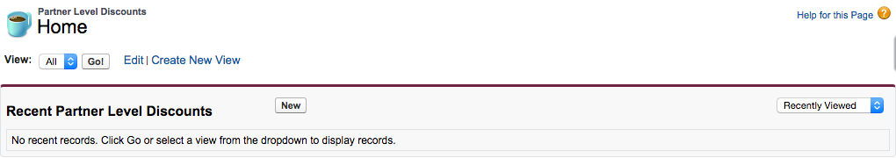
14. Set Fields, then Save & New  
    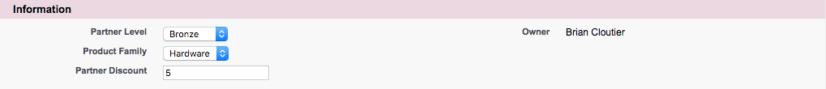
15. Create remaining Partner Discount Level records per table:

| Name | Partner Level | Product Family | Partner Discount |
| --- | --- | --- | --- |
| PLD-0001 | Bronze | Hardware | 5 |
| PLD-0002 | Bronze | Software | 2 |
| PLD-0003 | Bronze | Support | 3 |
| PLD-0004 | Silver | Hardware | 10 |
| PLD-0005 | Silver | Software | 5 |
| PLD-0006 | Silver | Support | 5 |
| PLD-0007 | Gold | Hardware | 15 |
| PLD-0008 | Gold | Software | 8 |
| PLD-0009 | Gold | Support | 7 |

# EX31: Partner Discounts by Product Family

Objective: Create a rule to automatically set the value of Partner Discount based on the account Partner Level as well as the quote line Product Family by querying the Partner Level Discount records created in EX30.

1. Navigate to the Price Rules tab
2. Click New  
   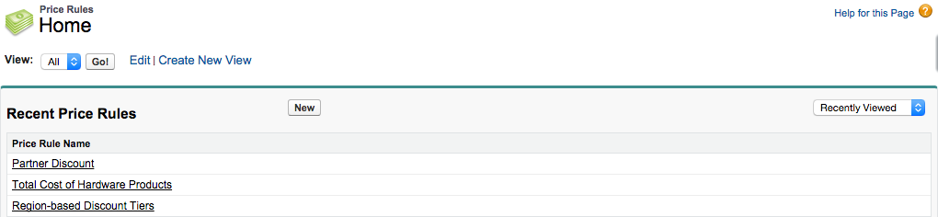
3. Open the Force.com Quick Access Menu, then click View Fields  
   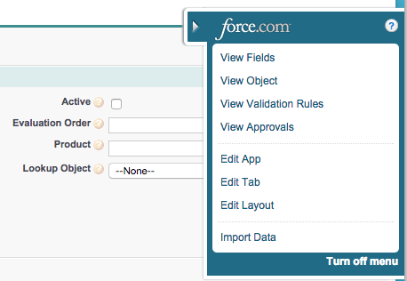
4. Click the Lookup Object link  
   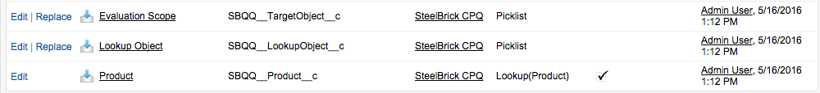
5. Click New in Values  
   
6. Enter API name of the Partner Level Discount Object, then Save  
   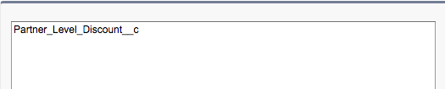
7. Return to the original Price Rule tab and refresh the page
8. Set field values, then Save  
   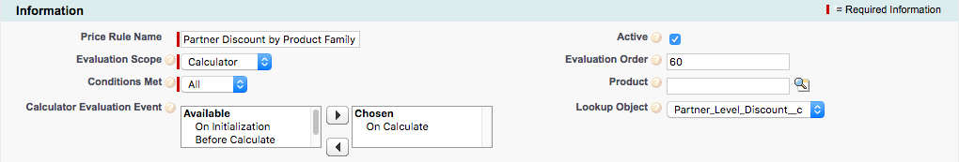
9. Click New Price Condition in Price Conditions  
   
10. Set field values, click Save  
    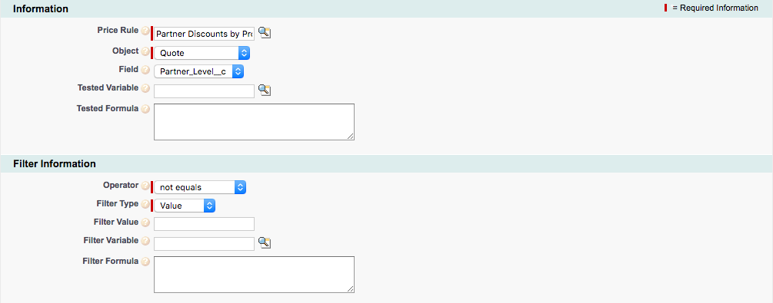
11. Navigate back to the Price Rule
12. Click New Lookup Query in Lookup Queries  
    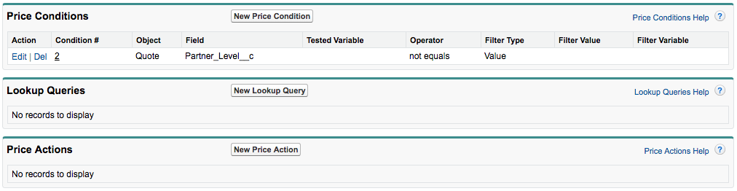
13. Open the Force.com Quick Access Menu, then click View Fields  
    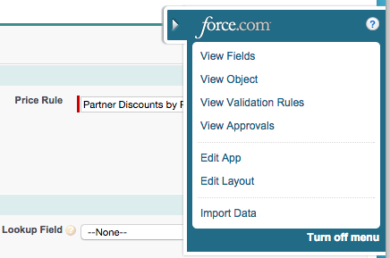
14. Click the Tested Field link  
    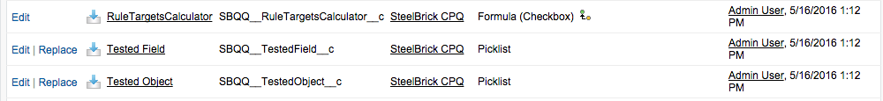
15. Click New in Values  
    
16. Enter name of the Quote Line Product Family field and Quote Partner Level field, then Save  
    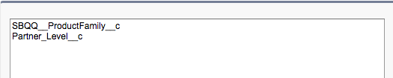
17. Return to Lookup Query object  
    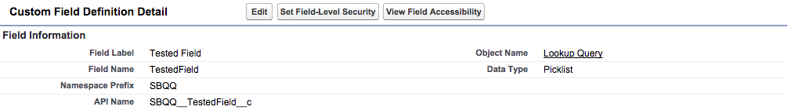
18. Click the Lookup Field link  
    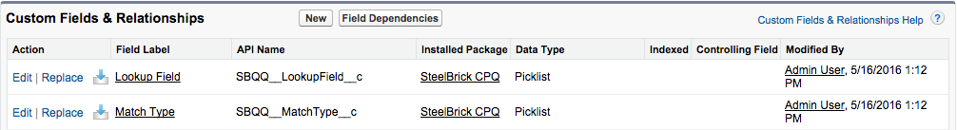
19. Click New in Values  
    
20. Enter API name of the Product Family and Partner Level from the Partner Discount Object, then Save  
    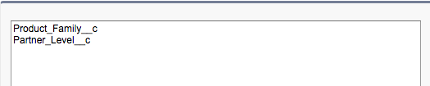
21. Return to the original Lookup Query tab and refresh the page
22. Set field values, then Save & New  
    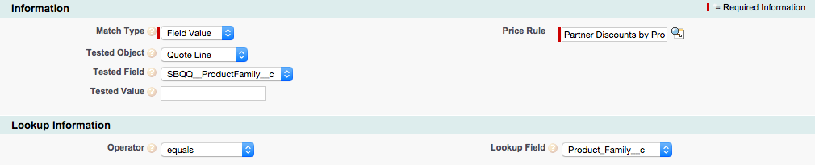
23. Set field values, then Save  
    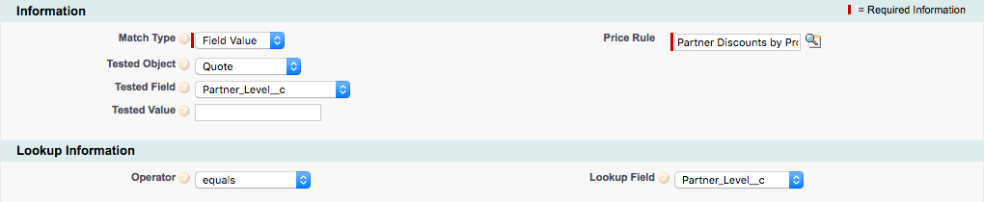
24. Return to the Partner Discounts by Product Family Price Rule
25. Click New Price Action in Price Actions  
    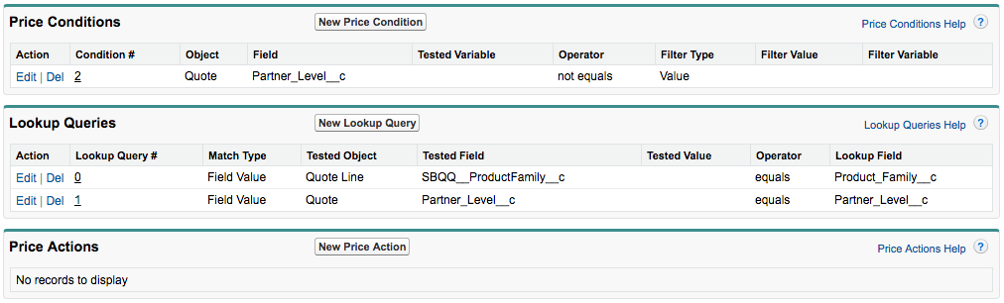
26. Open the Force.com Quick Access Menu, then click View Fields  
    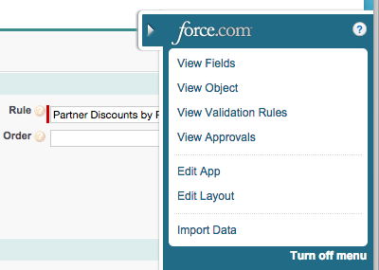
27. Click the Source Lookup Field link  
    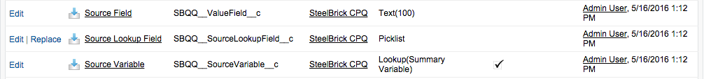
28. Click New in Values  
    
29. Enter API name of the Partner Discount field from the Partner Discount Object, then Save  
    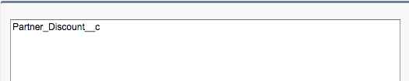
30. Return to the original Price Action tab and refresh the page
31. Set field values, then Save  
    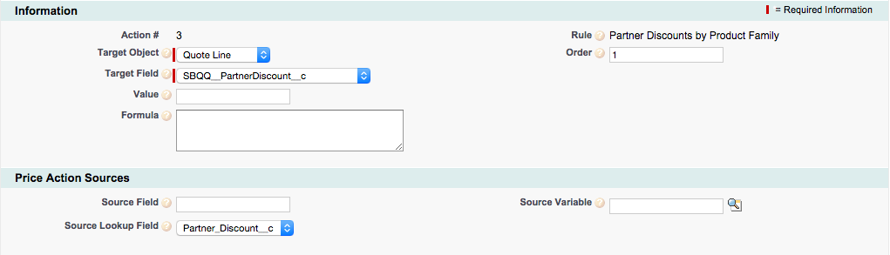

# EX36: Create a Quote Template

Objective: Create a basic template used to generate simple customer-facing proposals, in PDF format.

1. Navigate to the Quote Templates tab
2. Click New  
   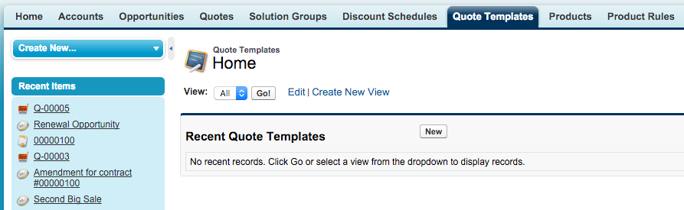
3. Set field values, then Save  
   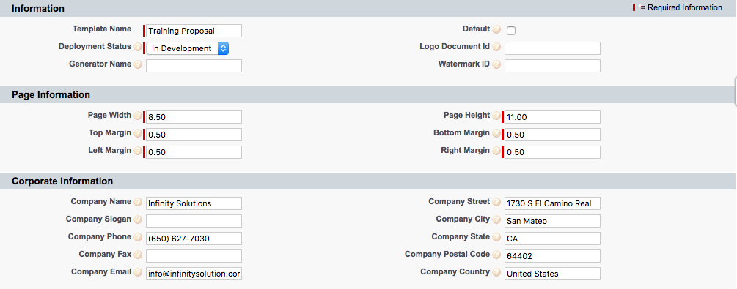
4. Navigate to any existing quote with line items, then click Preview Document  
   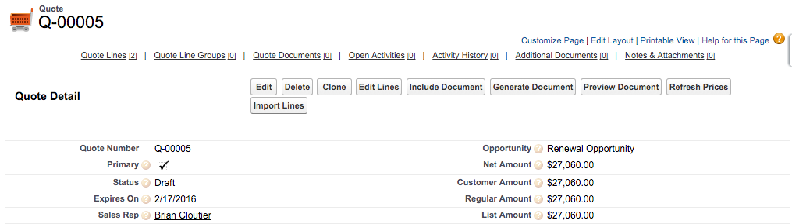

# 

# EX37: Upload a Logo File

Objective: Add a company logo to appear in the upper-left of the first page of the generated proposal.

1. Navigate to the Documents tab
2. Click New  
   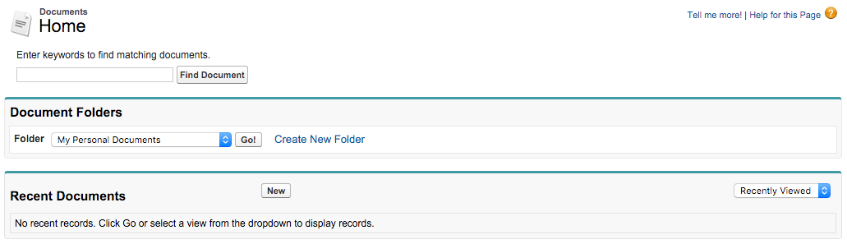
3. Set field values, click Choose File, select your file, then Save  
   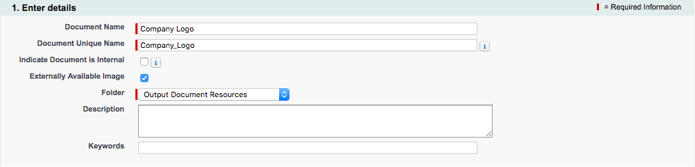  
   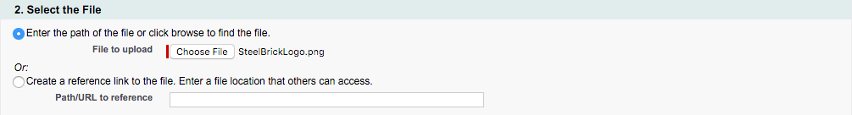
4. Copy the last portion of the URL  
   
5. Navigate to the Quote Template
6. Paste portion of URL into Logo Document ID, then Save  
   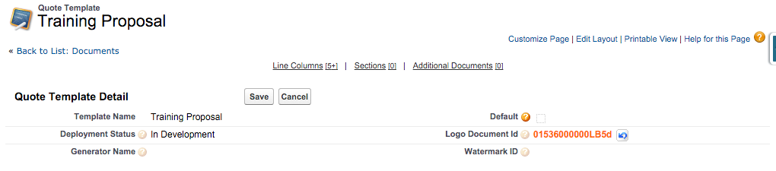

# EX38: Add Draft Watermark

Objective: Add a watermark that appears behind text on the generated proposal if the Quote field named Watermark Shown is true.

1. Navigate to the Documents tab
2. Choose the Output Document Resources folder (click Go! if already selected)  
   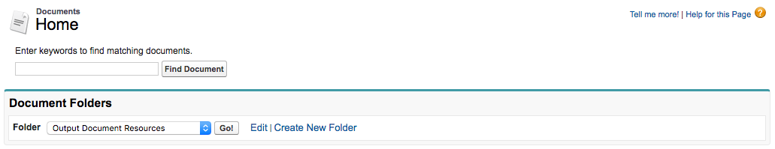
3. Click on Watermark.png link  
   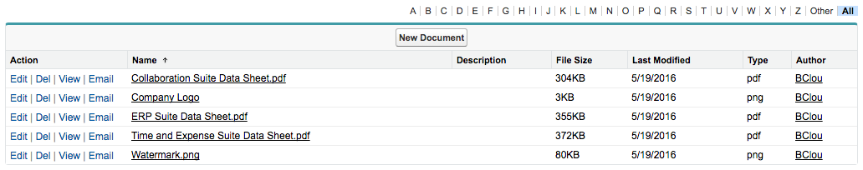
4. Copy the last portion of URL  
   
5. Navigate to the Quote Template
6. Paste portion of URL into Watermark ID, then Save  
   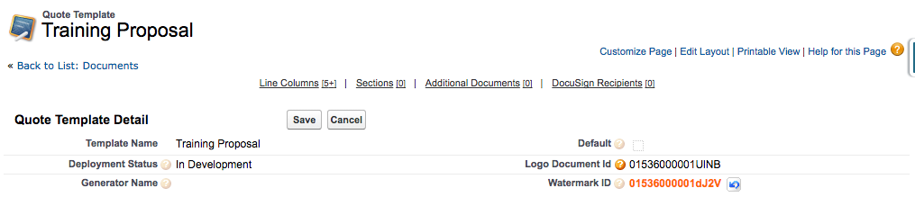
7. Navigate to any existing quote with line items
8. Update field value, then Save  
   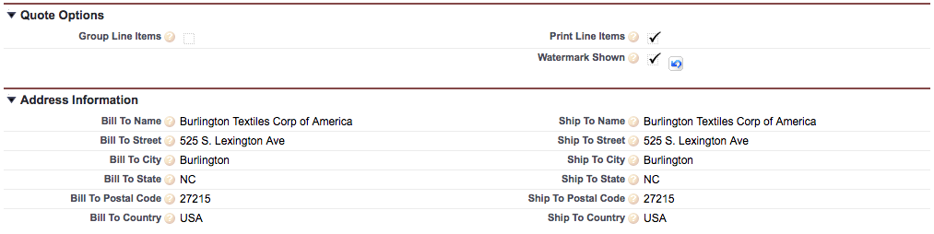

# EX39: Add Additional Documents

Objective: Allow sales reps to include supplemental PDFs concatenated to the generated proposal.

1. Navigate to the Documents tab
2. Choose the Output Document Resources folder (click Go! if already selected)  
   
3. Click on Collaboration Suite Data Sheet.pdf link  
   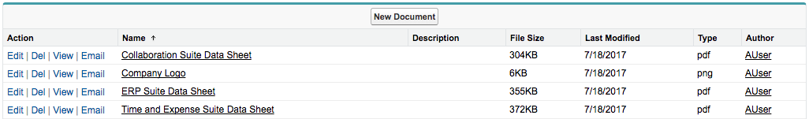
4. Copy the last portion of URL  
   
5. Navigate to the Quote Template
6. Click New Additional Document in Additional Documents  
   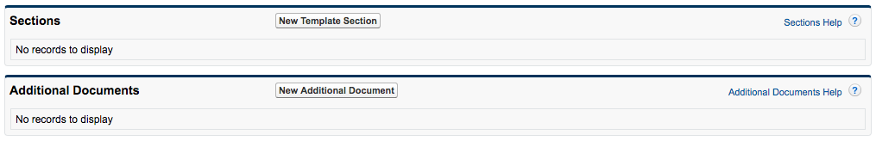
7. Paste portion of URL into Logo Document ID, enter Display Order, then Save  
   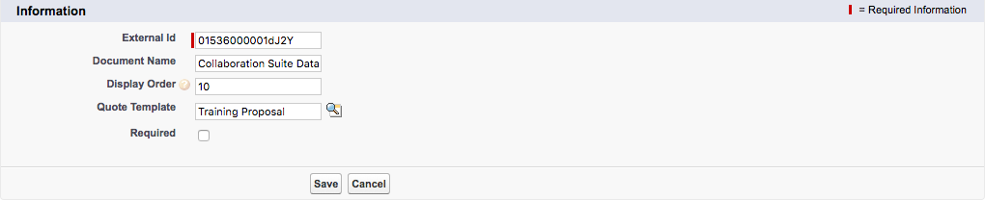
8. Repeat steps 1-7 for ERP Suite Data Sheet.pdf (display order 20)

# EX40: Assemble Custom Document

Objective: Use provided Template Content to replace the simple structure of the standard proposal with customizable content. The updated proposal will include a cover page, a page for a cover letter, the familiar quote line table, updated headers, and an expanded signature block.

1. Navigate to the Quote Template
2. Click New Template Section in Sections  
   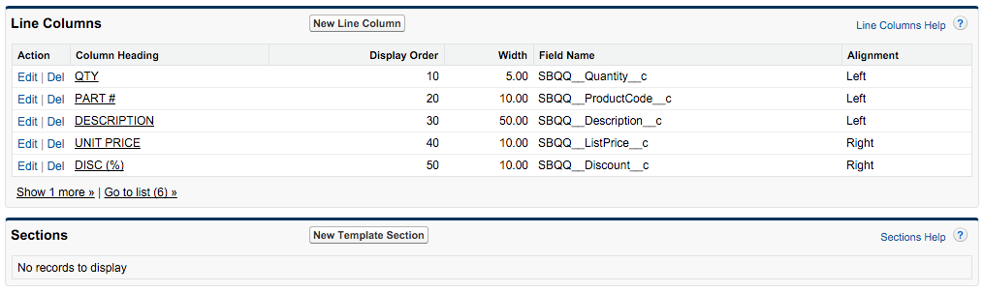
3. Set field values, then click Save & New  
   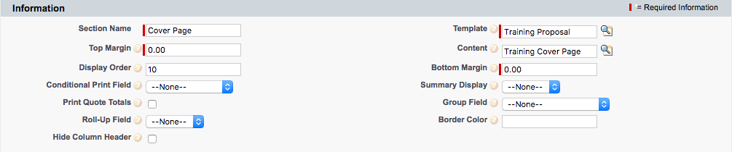
4. Repeat step 3 to create sections for the following template content:
   1. Training Cover Letter (display order 20, set page break to Before)
   2. Training Tail Header (display order 30, set page break to Before)
   3. Training Prepared For (display order 40)
   4. Training Line Items (display order 50)
   5. Training Signature Block (display order 70)

# EX44: Adjust Line Columns

Objective: Change the Part # column to display Product Name instead, while adjusting the width of the column to accommodate longer text. Reduce the width of the Description column to account for the larger Product Name column.

1. Navigate to the Quote Template
2. Click Edit next to the Part # column  
   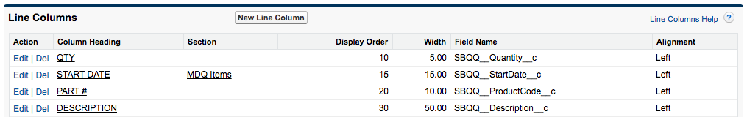
3. Update field values, then Save  
   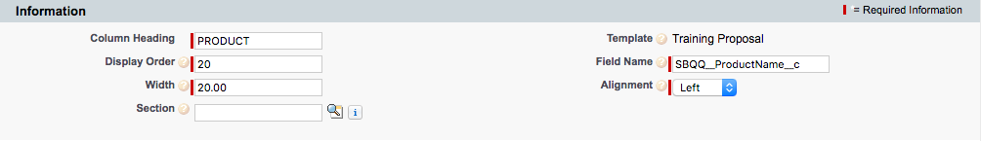
4. Click Edit next to the Description column  
   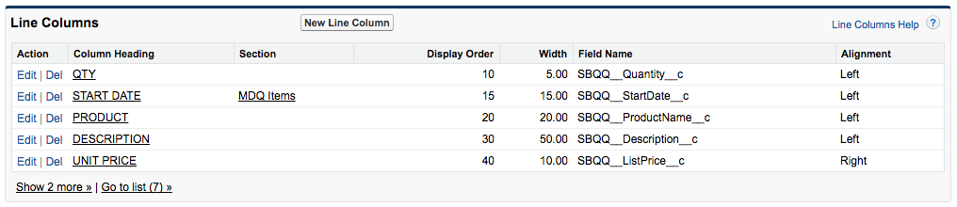
5. Update field value, then Save  
   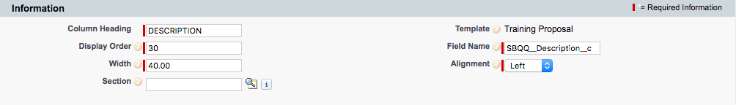

# EX45: Conditional Discount Column

Objective: Setup the Discount column to appear only when sales reps have manually entered Quote Line discretionary discounts, otherwise the column will disappear and the other columns will grow to cover the gap.

1. Navigate to the Quote Template
2. Click Edit next to the Disc (%) column  
   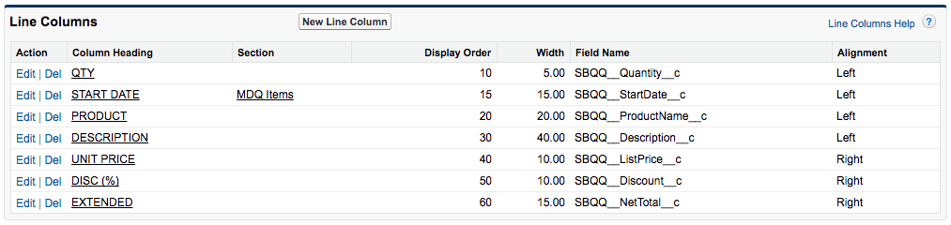
3. Open the Force.com Quick Access Menu, then click View Fields  
   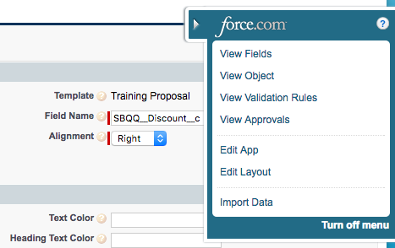
4. Click the Conditional Print Field link  
   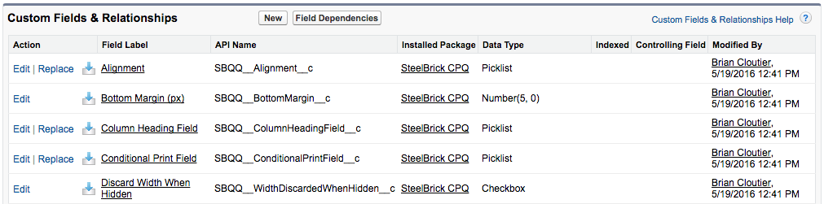
5. Click New in Values  
   
6. Enter API name of the Quote Line Additional Disc. (Amt) field, then Save  
   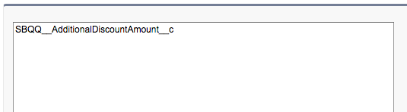
7. Return to the original Line Column tab and refresh the page
8. Set field value, then Save  
   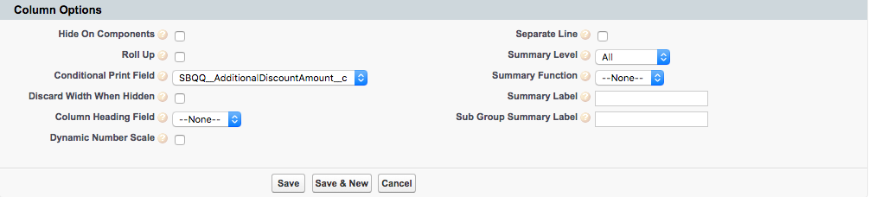

# EX46: Conditional Pricing Columns

Objective: Allow sales reps to control visibility of the Unit Price and Extended columns by creating a Quote checkbox field named Show Pricing Columns. When false, the columns will disappear and the other columns will grow to fill the gap.

1. Navigate to Setup | Create | Objects | Quote
2. Click New in Custom Fields & Relationships  
   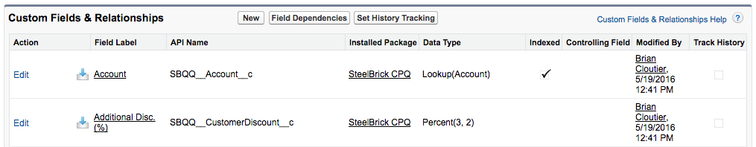
3. Choose Checkbox then click Next  
   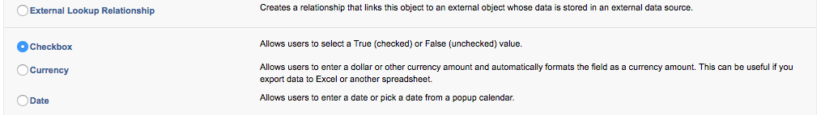
4. Enter Show Pricing Columns as the field label, then click Next, Next, Save  
   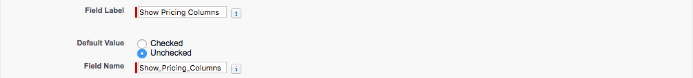
5. Navigate to the Quote Template
6. Click Edit next to the Unit Price column  
   
7. Open the Force.com Quick Access Menu, then click View Fields  
   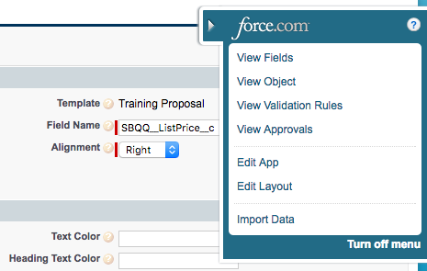
8. Click the Conditional Print Field link  
   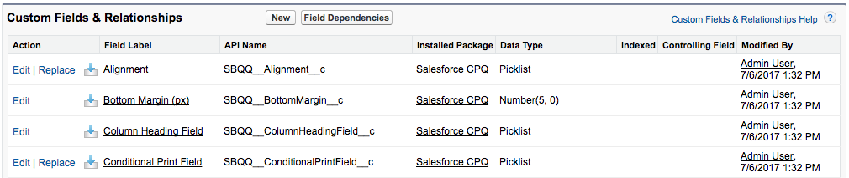
9. Click New in Values  
   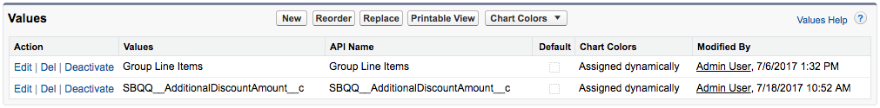
10. Enter API name of the Quote Show Pricing Columns field, then Save  
    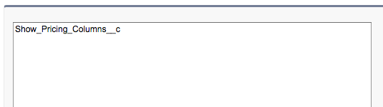
11. Return to the original Line Column tab and refresh the page
12. Set field value, then Save  
    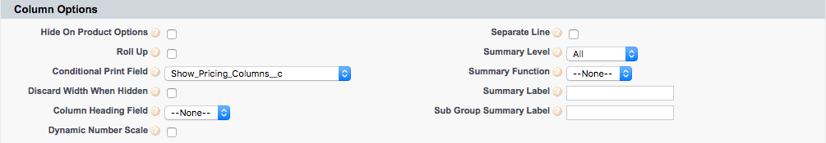
13. Repeat steps 5, 6 and 13 for the Extended line column

# 

# EX50: Conditional Line Item Tables

Objective: Allow sales reps to control whether the line item table combines all line items into a single table, or separate one-time and subscription products into two tables. The custom Quote field named Separate by Subscription Type will determine if separate tables are created.

1. Navigate to Setup | Create | Objects | Quote
2. Click New in Custom Fields & Relationships  
   
3. Choose Checkbox, then click Next  
   
4. Enter Separate by Subscription Type as the field label, then click Next, Next, Save  
   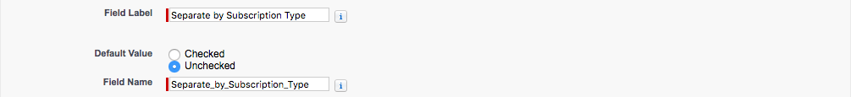
5. Click New in Custom Fields & Relationships  
   
6. Choose Formula then click Next  
   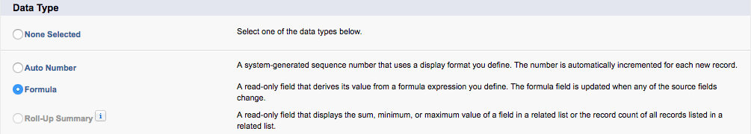
7. Enter Combine Subscription Type as the field label, choose Checkbox as the return type, then click Next  
   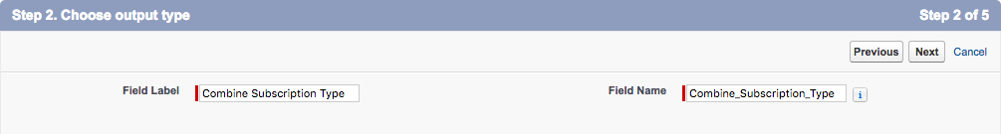  
   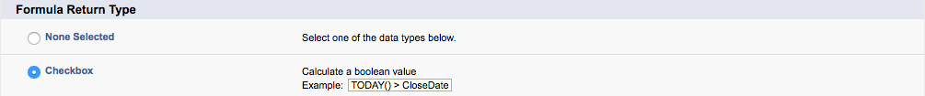
8. Set formula body as described below, then click Next, Next, Save  
    IF(Separate_by_Subscription_Type__c, FALSE, TRUE)
9. Navigate to the Quote Template
10. Click Edit next to the Line Items section  
    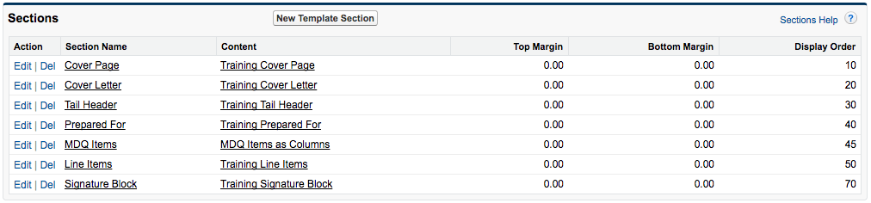
11. Open the Force.com Quick Access Menu, then click View Fields  
    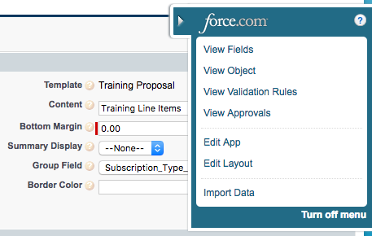
12. Click the Conditional Print Field link  
    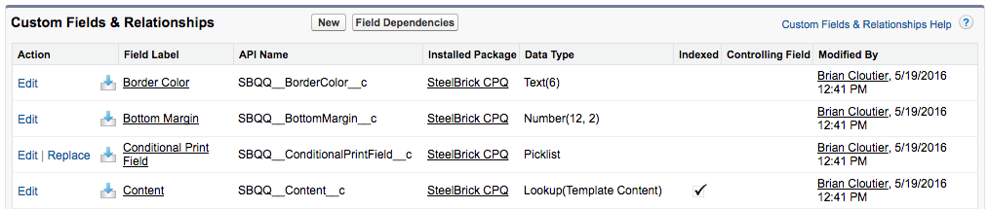
13. Click New in Values  
    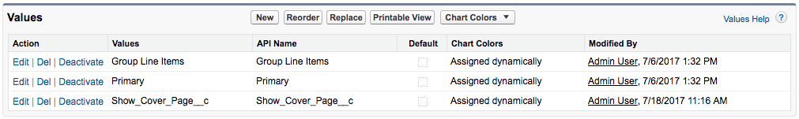
14. Enter API names of the custom Quote fields, then Save  
    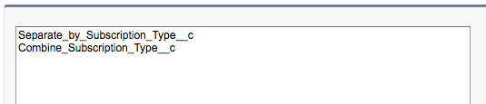
15. Return to the original Template Section tab and refresh the page
16. Set field value, then Save  
    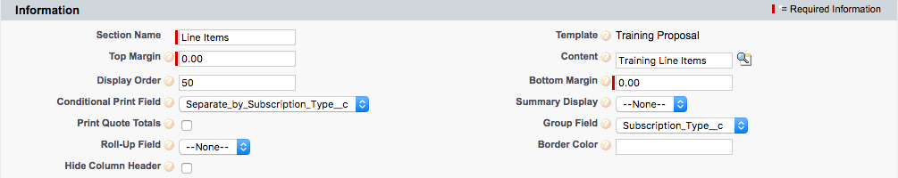
17. Click Line Items section link  
    
18. Click the Clone button  
    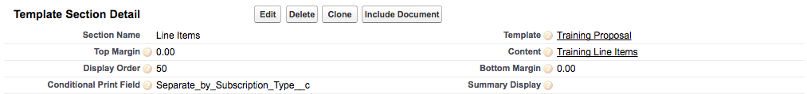
19. Update fields, then Save

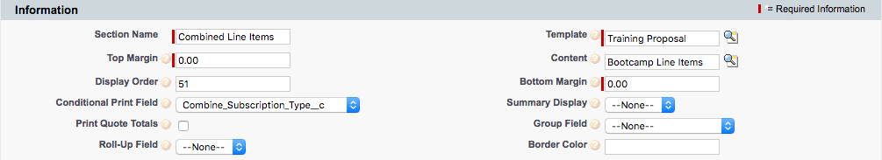

# 

# EX52: Quote Terms Section

Objective: Display premade quote terms on a new page in the generated proposal, beginning with premade header content, and located immediately before the signature block.

1. Navigate to the Template Content tab
2. Click New  
   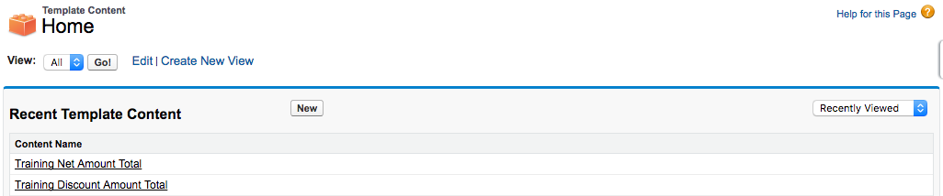
3. Choose Quote Terms, then click Continue  
   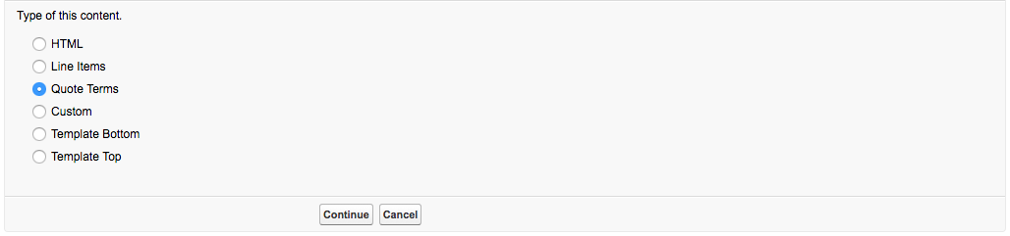
4. Set field value, then Save  
   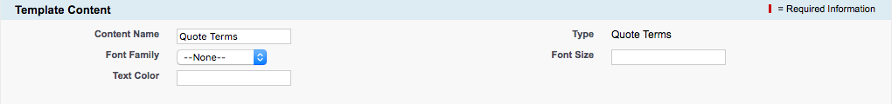
5. Navigate to the Quote Template
6. Click New Template Section in Template Sections  
   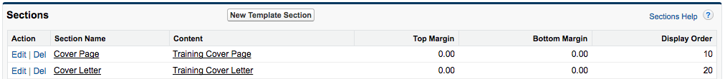
7. Set field values, then click Save & New  
   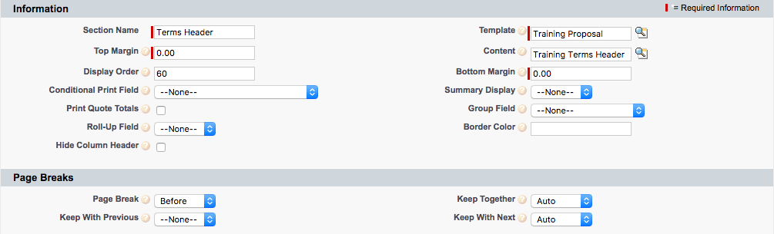
8. Set field values, then Save  
   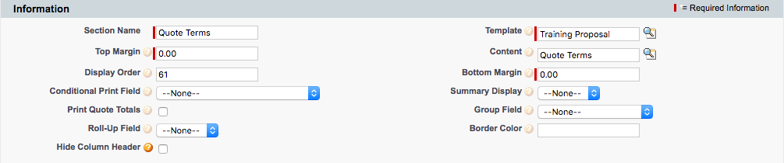

# EX53: Quote Term with Merge Field

Objective: Update an existing quote term to include the Quote Billing Name and Expiration Date information, inline with static text.

1. Navigate to the Quote Terms tab
2. Click Go!  
   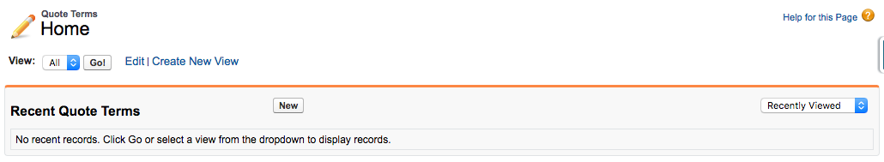
3. Click Edit next to the term beginning with “This quote is presented…”  
   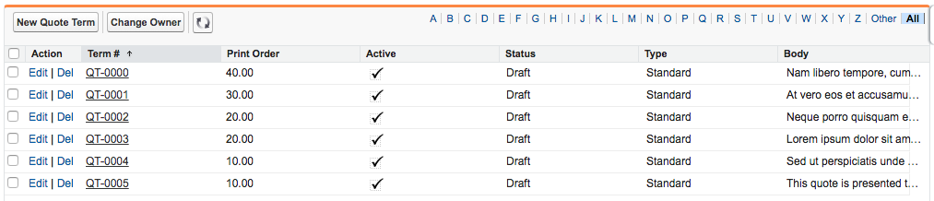
4. Update the term body to include the highlighted text, then Save  
   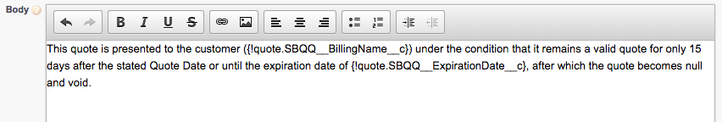

# EX54: Conditional Quote Term

Objective: Configure a quote term so that it only appears in the generated document when the Quote field named Status is equal to ‘Draft’, ‘In Review’, or ‘Denied’.

1. Navigate to the Quote Terms tab
2. Click New  
   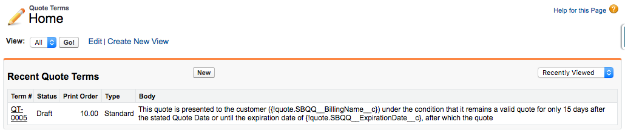
3. Set field values, then Save  
   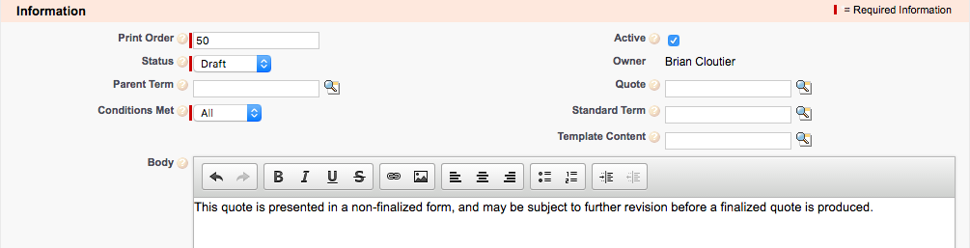
4. Click New Term Condition in Term Conditions  
   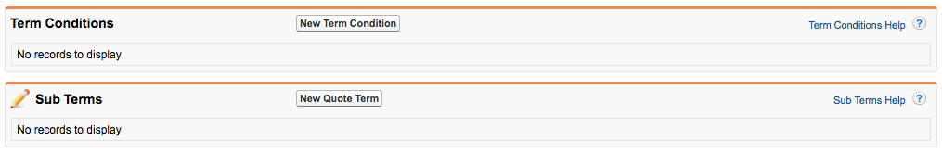
5. Open the Force.com Quick Access Menu, then click View Fields  
   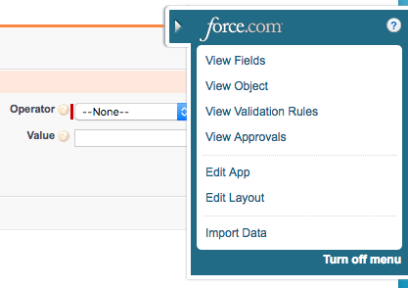
6. Click the Tested Field link  
   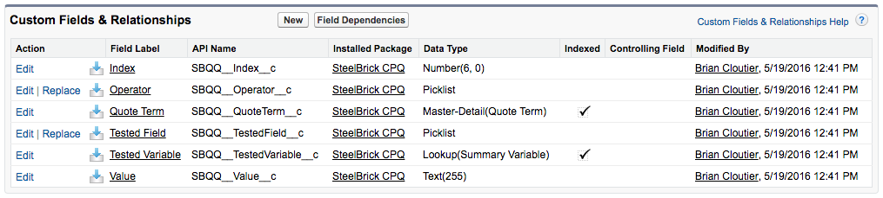
7. Click New in Values  
   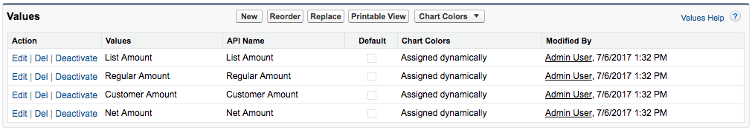
8. Enter API name of the Quote Status field, then Save  
   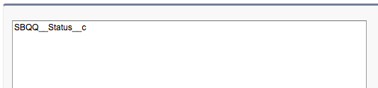
9. Return to the original Term Condition tab and refresh the page

Set field values, then Save

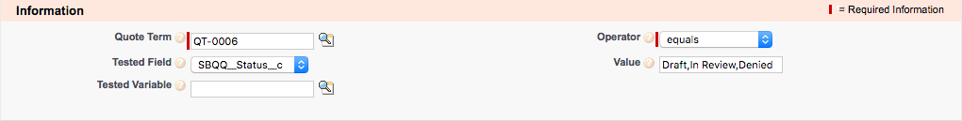

# 

# EX33: Create a Contract and Renewal Opportunity

Objective: Allow Salesforce CPQ to create a Contract record based on an Opportunity that contains subscription products. On the Contract record, Subscription records will be created automatically. Then, allow Salesforce CPQ to create a renewal Opportunity that represents the potential future sale of a continued subscription.

1. Navigate to the Account created on the first day
2. Click New Opportunity in Opportunities
3. Set field values, then Save  
   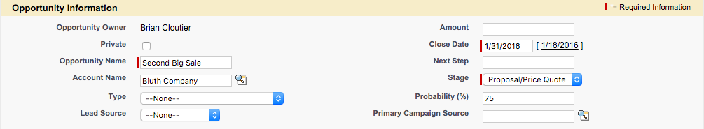
4. Click New Quote in Quotes
5. Set field values, then Save  
   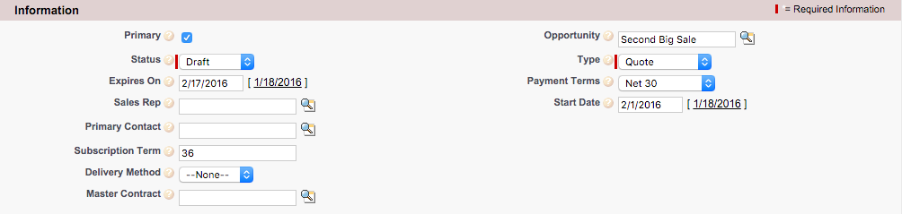
6. Click Save to Choose Price Book popup  
   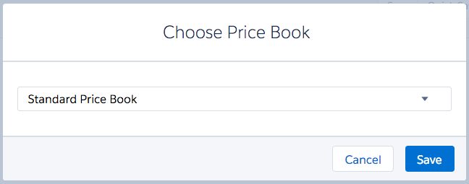
7. Click Add Products  
   
8. Choose the following Products, then click Select  
   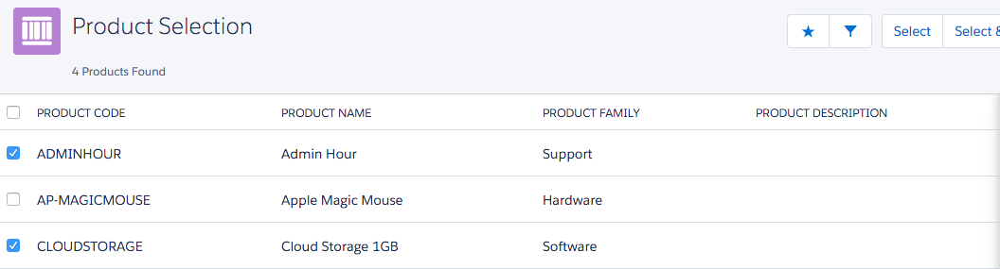
9. Save the Quote  
   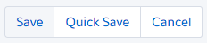
10. Return to the Opportunity
11. Set field values, then Save  
    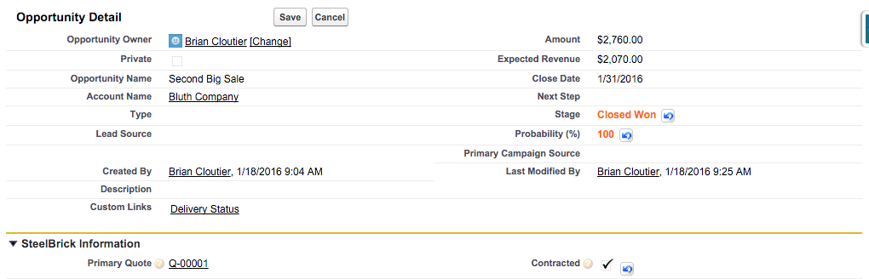
12. Refresh the opportunity page
13. Click the Contract Number link in Contracts  
    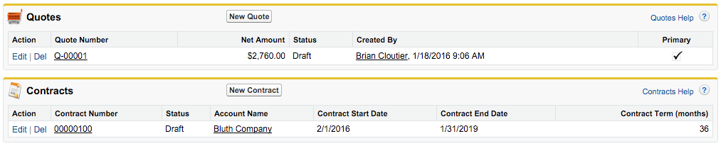
14. Click the Activate button  
    
15. Click OK if a warning popup appears
16. Navigate back to the Contract
17. Set field values, then Save  
    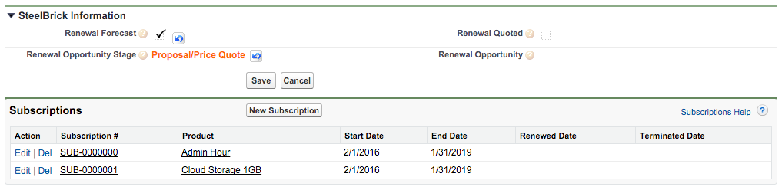

# EX34: Create Amendment Opportunity and Quote

Objective: Use the amend functionality to update an existing Contract to include higher quantities of subscription products, prorated for the remaining duration of the Contract. Salesforce CPQ will automatically create an amendment Opportunity and Quote during this process. When the amendment Opportunity is flagged ‘contracted’ the Renewal Opportunity from EX38 is automatically updated.

1. Navigate to the original Contract
2. Click Amend  
   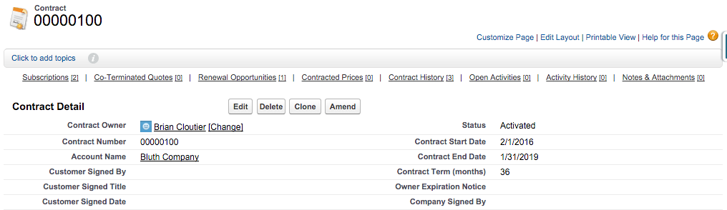
3. Click Amend on subscription preview page  
   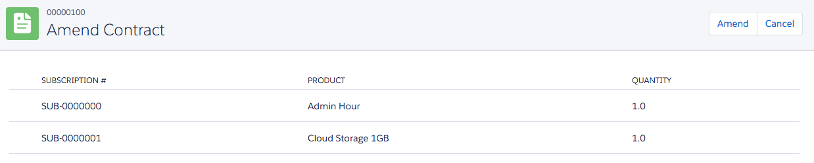
4. Set start date, adjust quantity, then Calculate  
   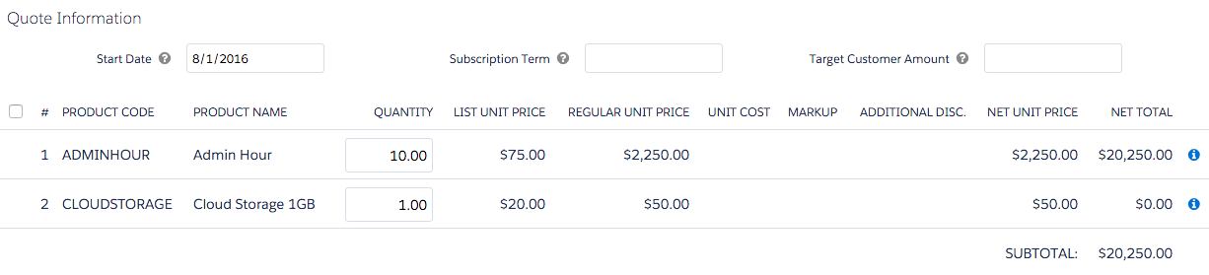
5. Save the Quote  
   
6. Navigate to the Amendment Opportunity
7. Set field values, then Save  
   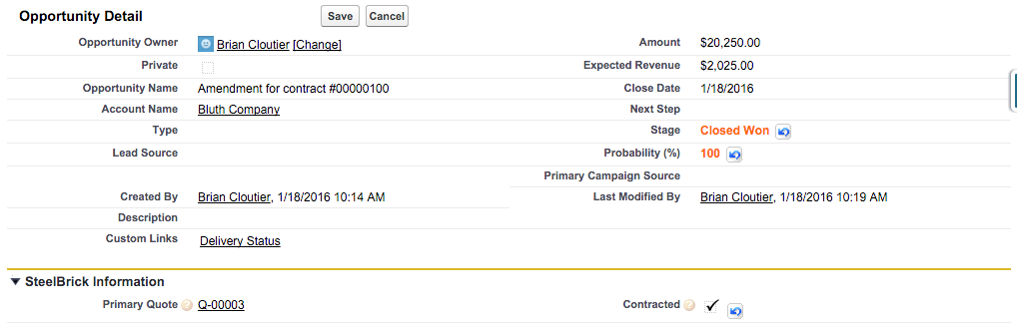

# EX35: Create a Renewal Quote

Objective: Allow Salesforce CPQ to create a Quote record on the renewal Opportunity from EX38. This quote will include Opportunity Products from the renewal Opportunity, and may be further modified, just like any other quote.

1. Navigate to the Contract
2. Set Renewal Quoted, then Save  
   